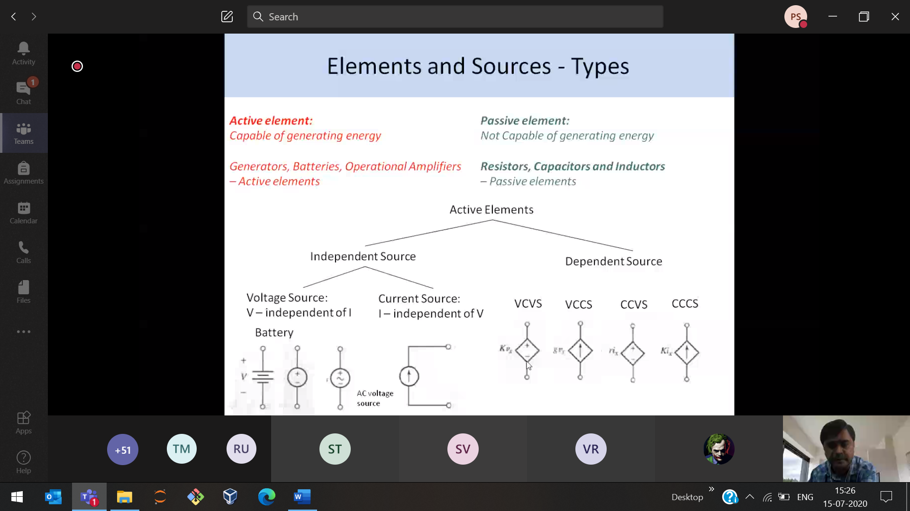

This square type 🡪 Dependent source

Circle 🡪 independent

VCVS 🡪 Voltage Controlled Voltage Source  
VCCS 🡪 Voltage Controlled Current Source

CCVS 🡪 Current Controlled Voltage Source  
CCCS 🡪 Current Controlled Current Source

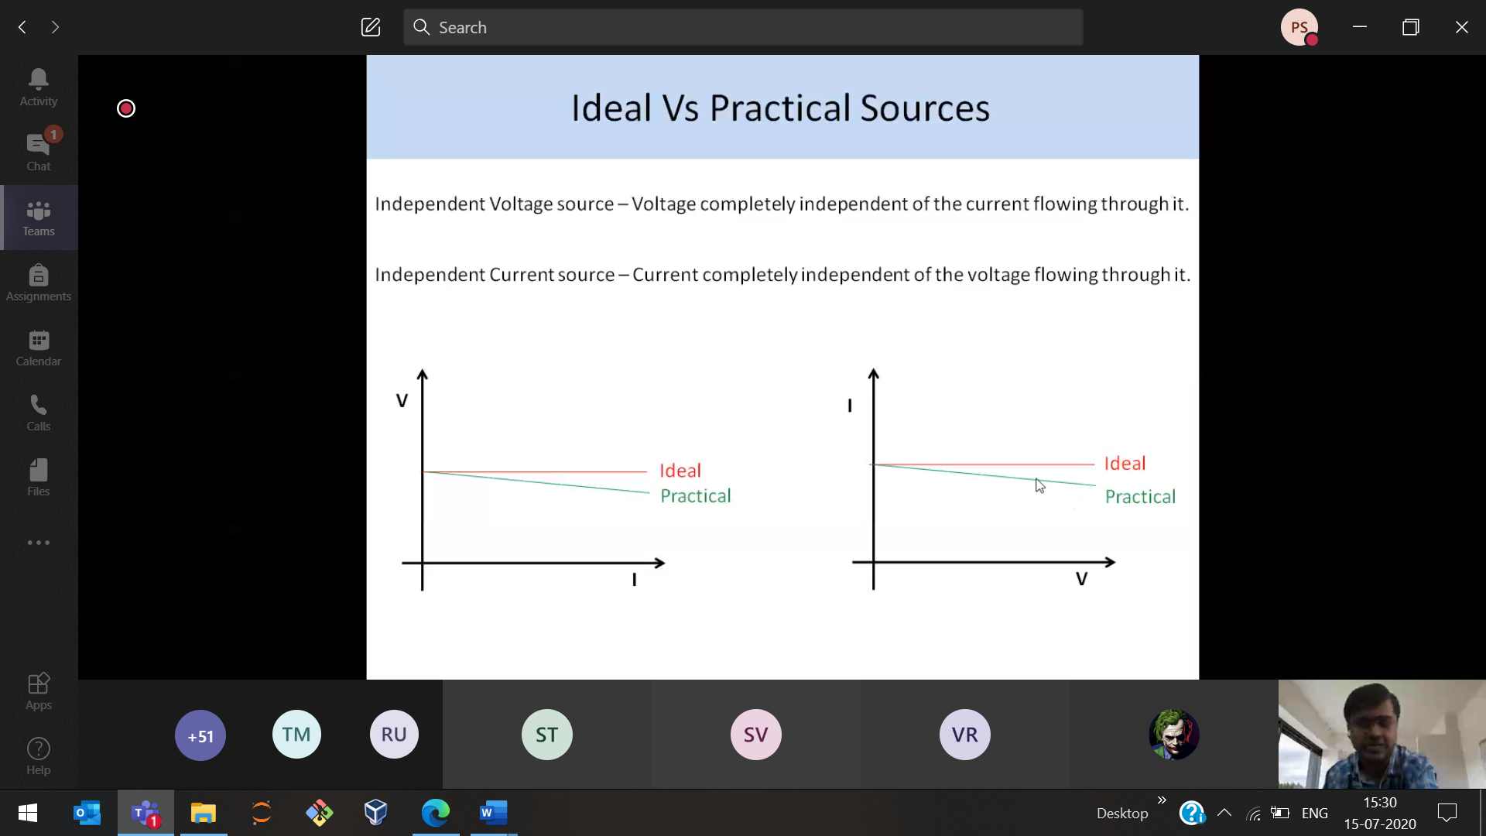

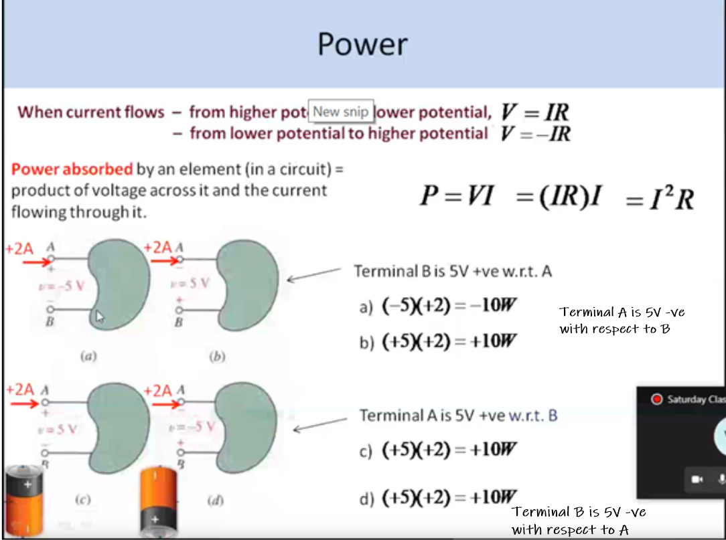

Seeing from -ve/+ve point of view 🡪 -ve/+ve Voltage

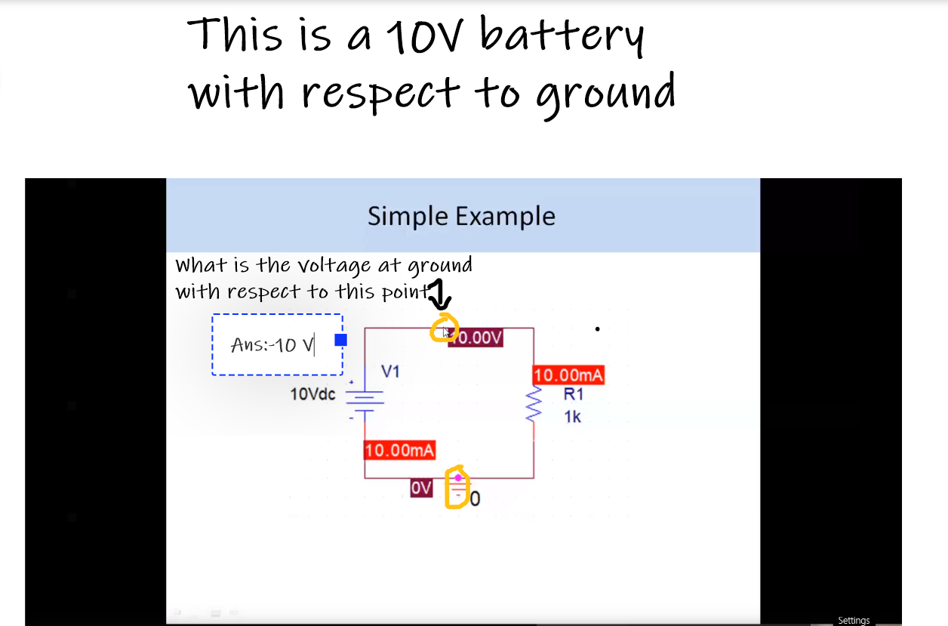

Multimeter 🡪 Red is connected to the +ve side of the battery

Black is connected to the -ve side of the battery

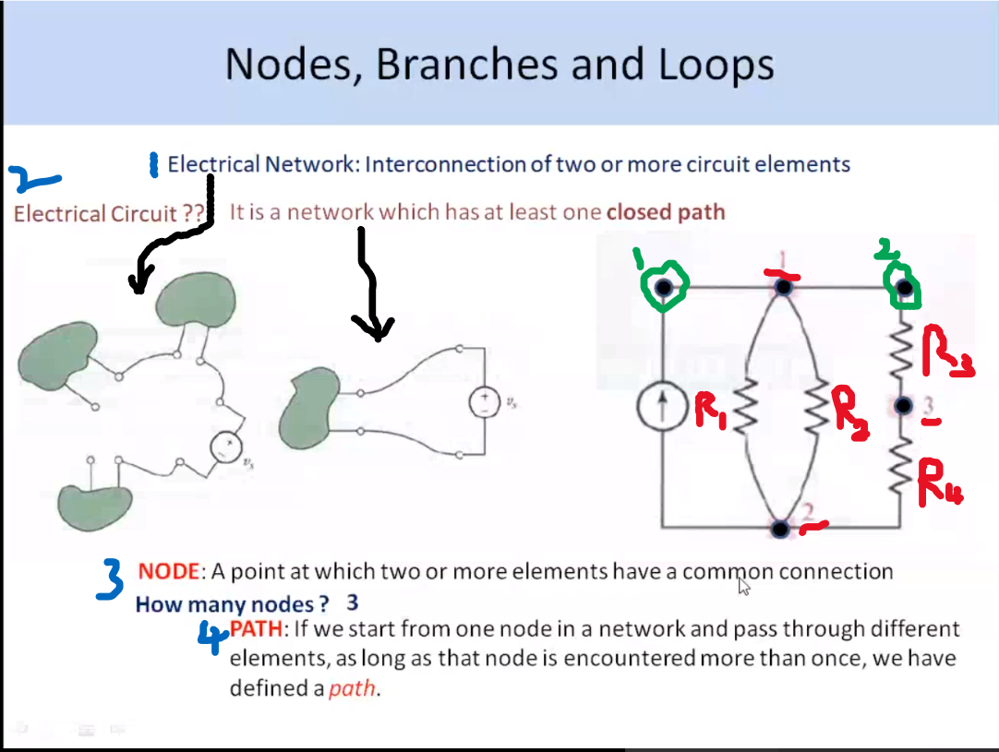

Circuit(closed) is a sub-set of network

Red-points:

Point-1 : Has a common connection to R1 and R2

Point-2 : Has a common connection to R1 and R2

Point-3 : Has a common connection to R3 and R4

Green-points:

Point-1 : No connection of elements

Point-2 : Only R3 is connected (1<2) 🡪 Not considered as a node

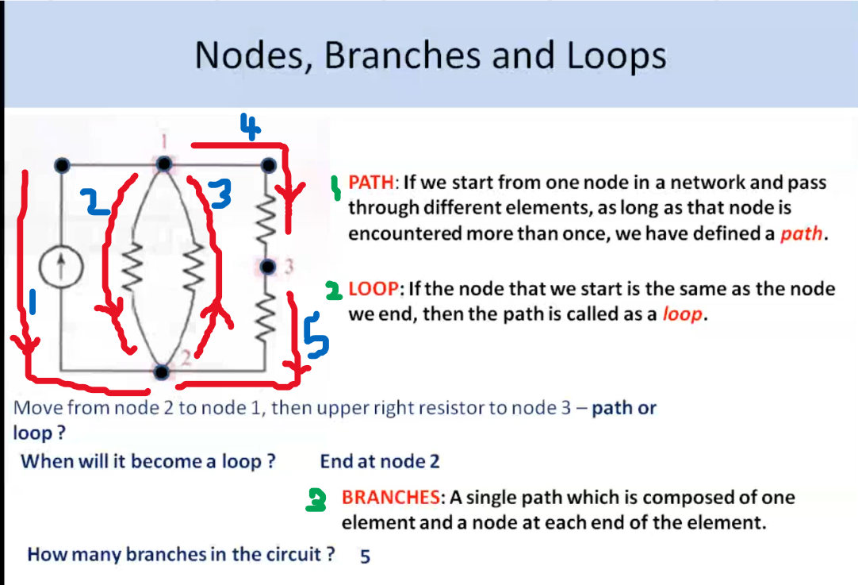

Path : Started from Node-2, and we should face the Node-2 once again in the path.

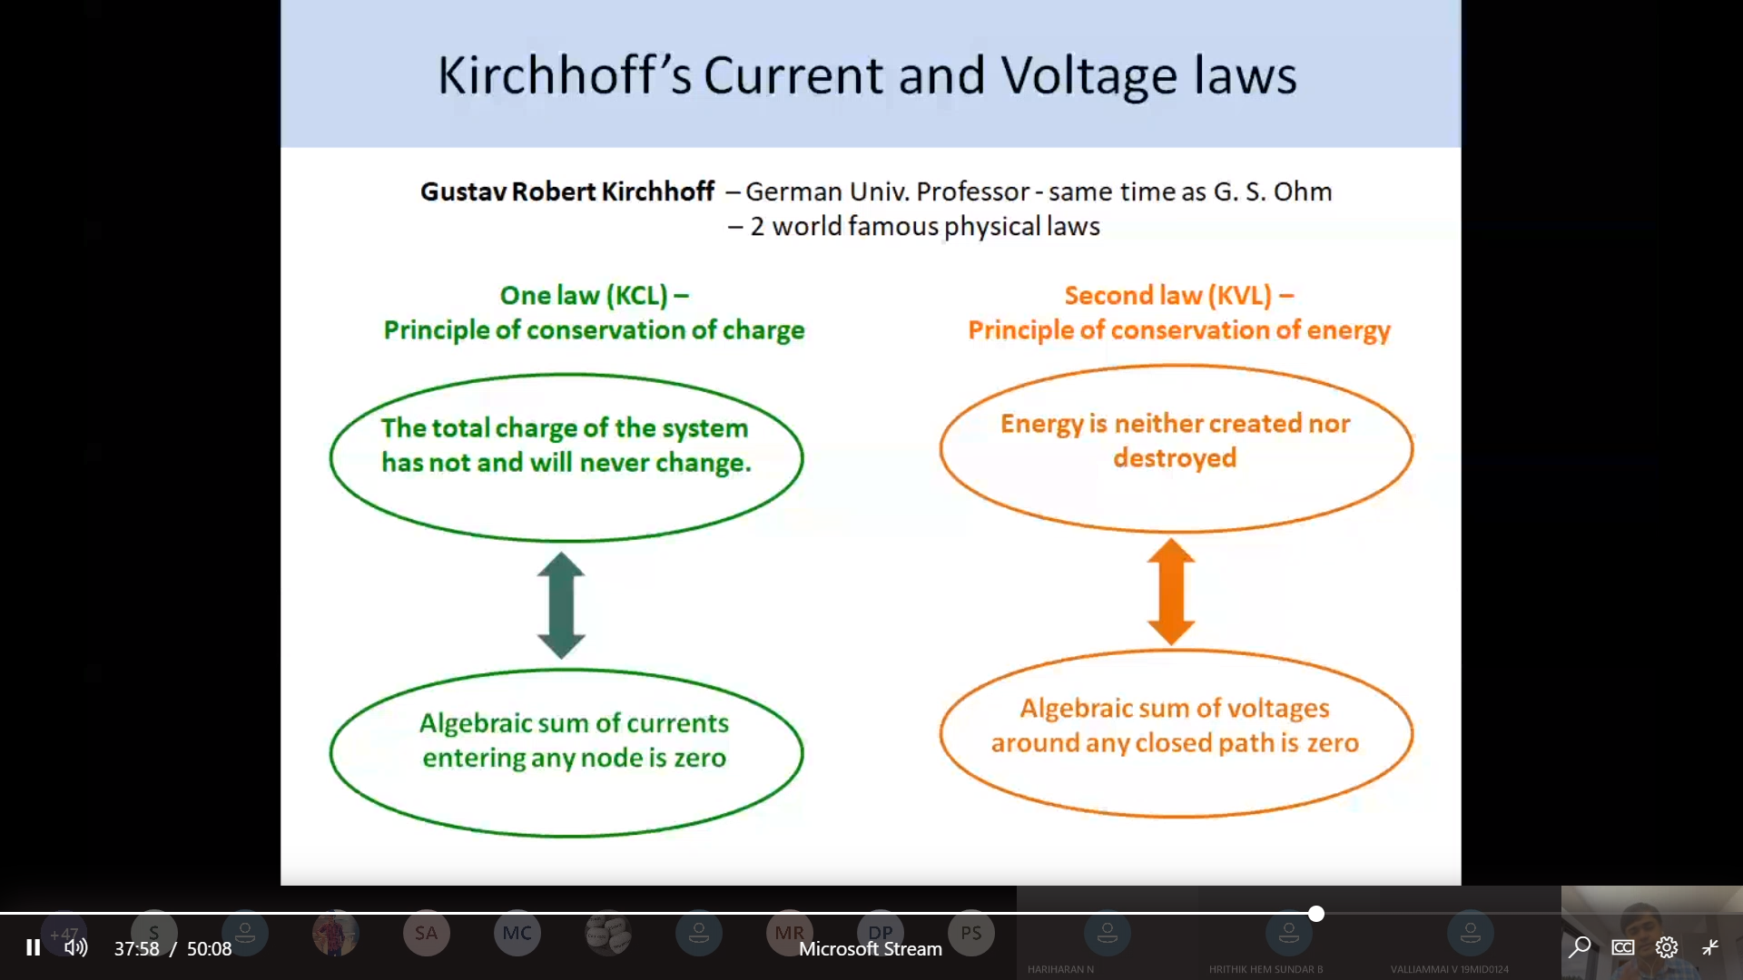

Conservation of charges Conservation of energy

**Kirchhoff’s current law** : It states that sum of the current entering a circuit junction is exactly equal to the total current leaving the same junction. This is because it has no other place to go as no charge is lost.

**Kirchhoff’s voltage law** : In any closed loop network, the total **voltage** around the loop is equal to the sum of all the **voltage** drops within the same loop” which is also equal to zero. In other words the algebraic sum of all **voltages** within the loop must be equal to zero.

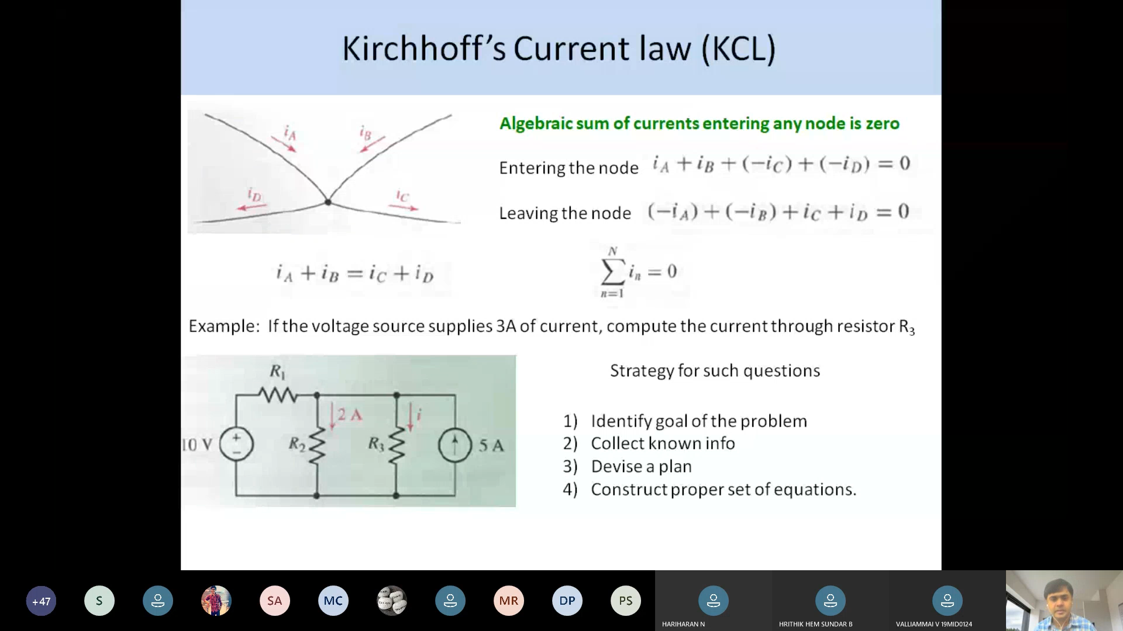

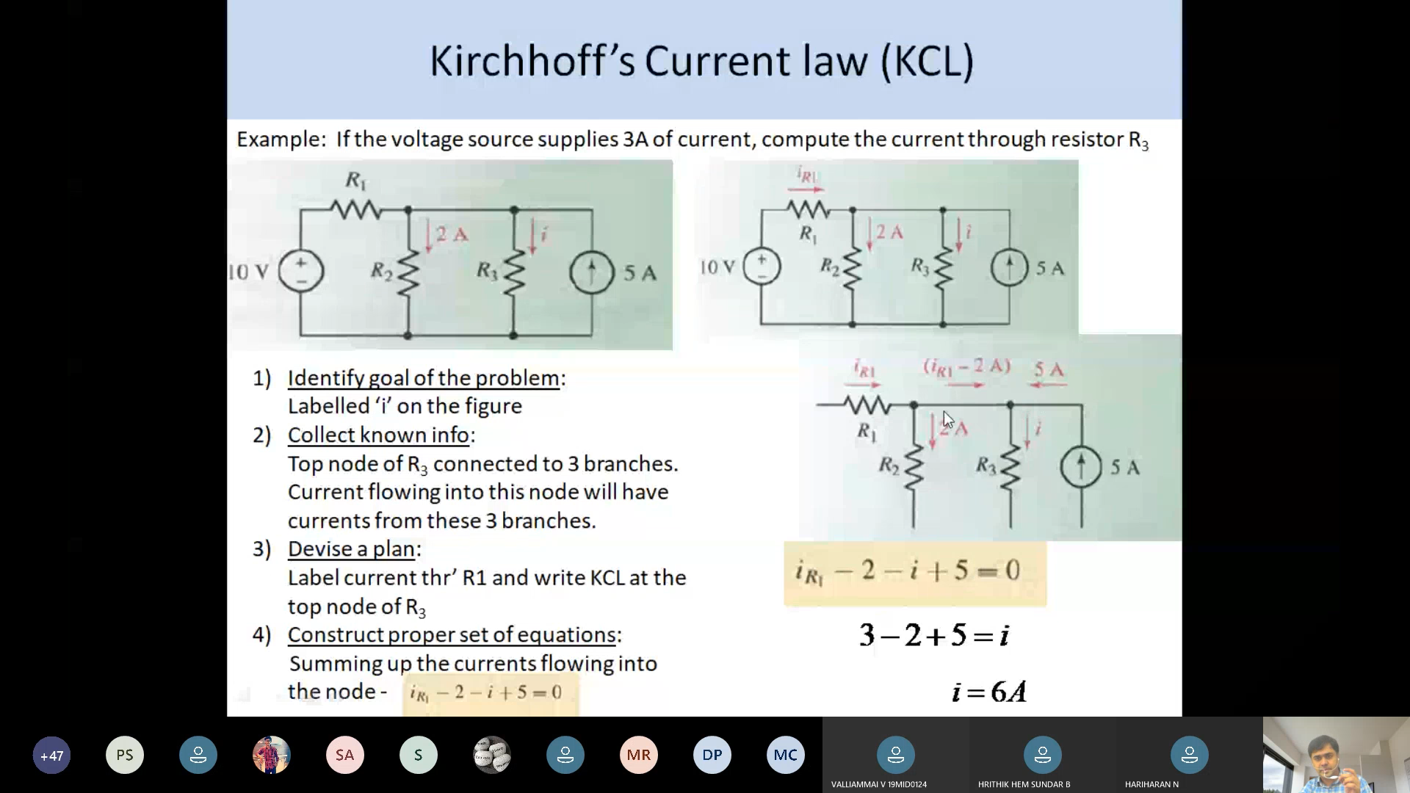



6 nodes are in circuit

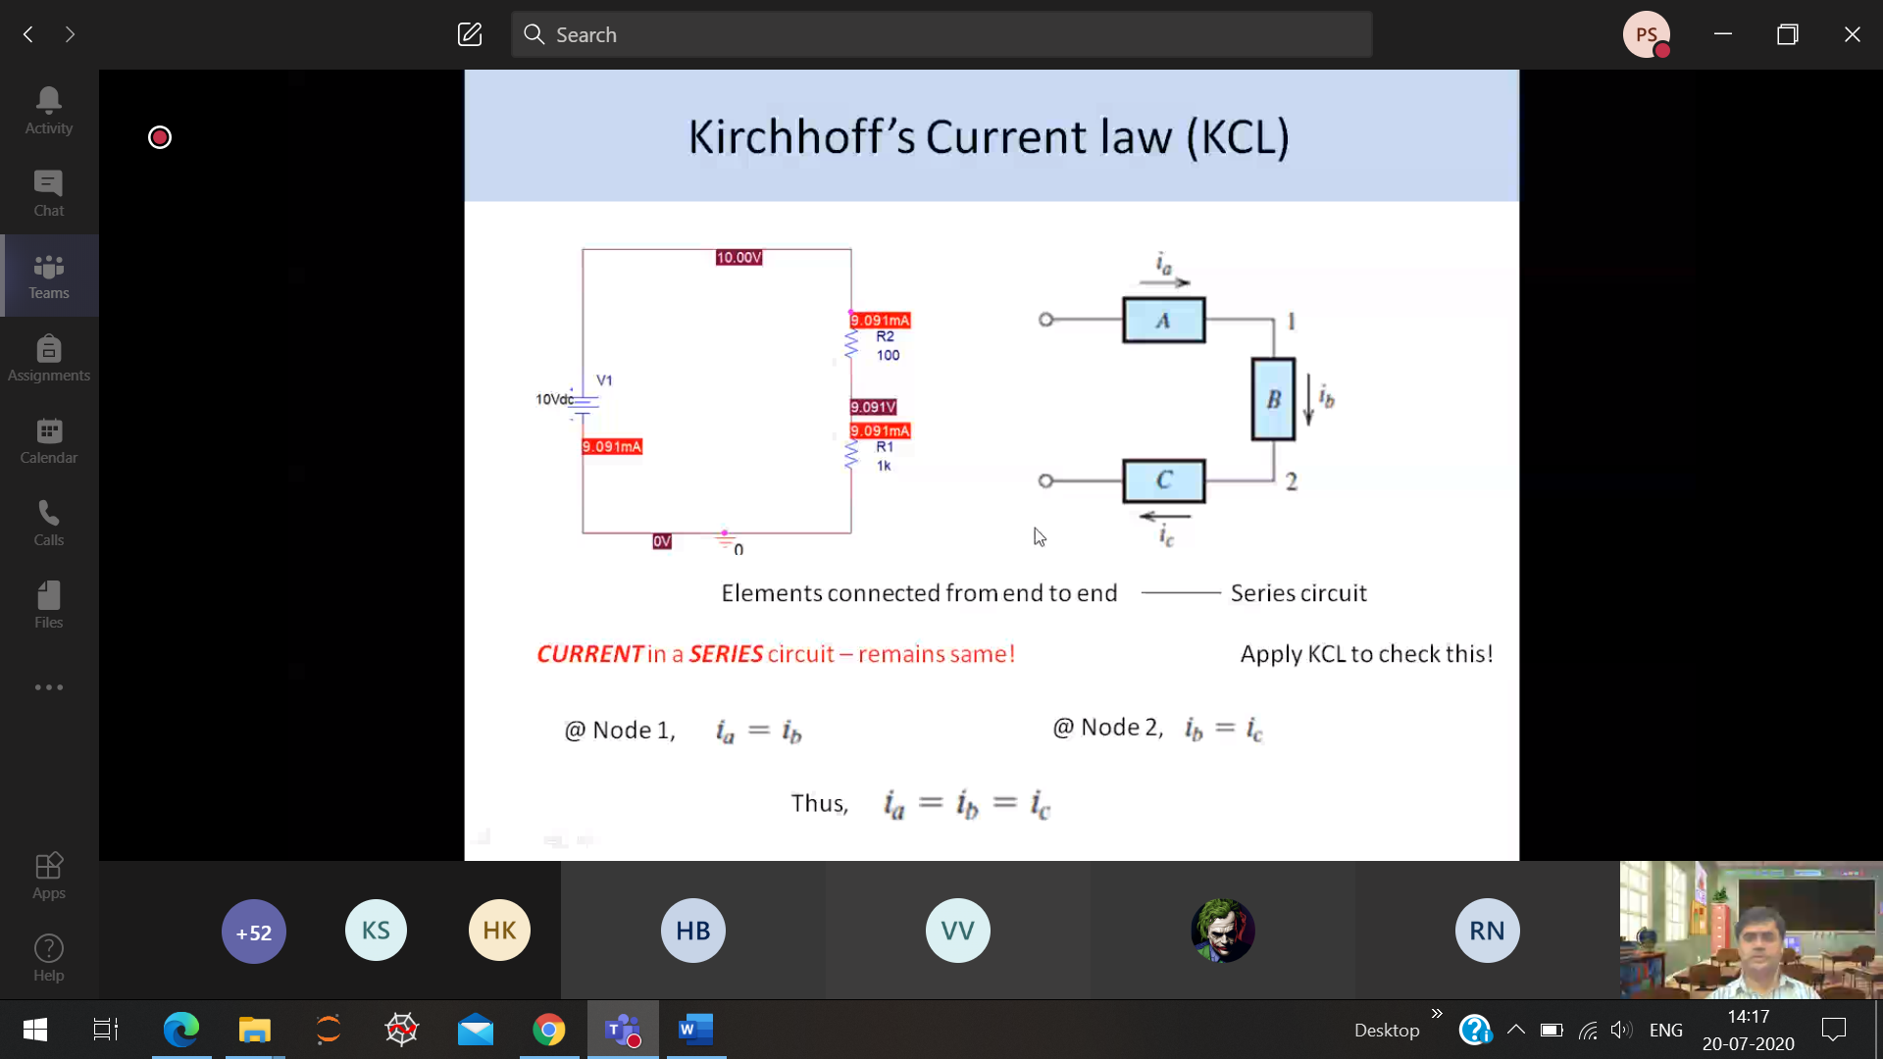

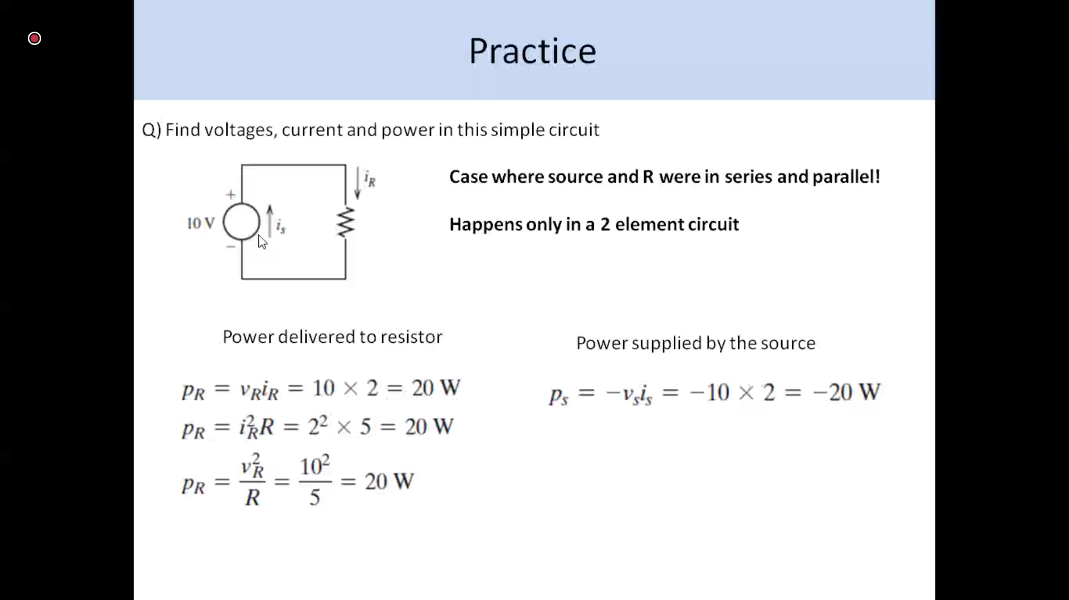

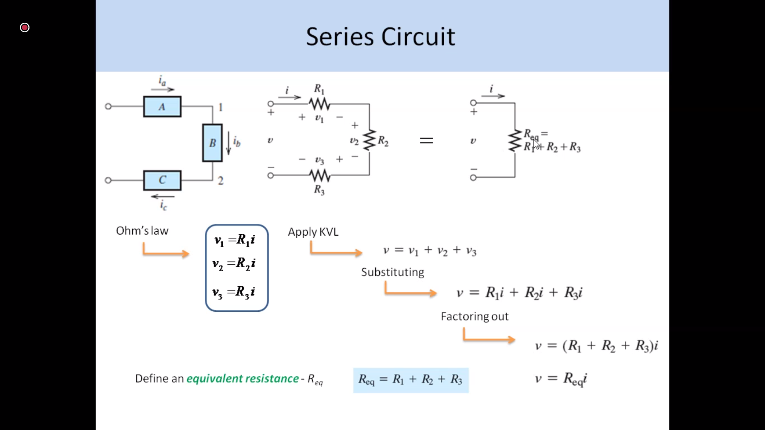

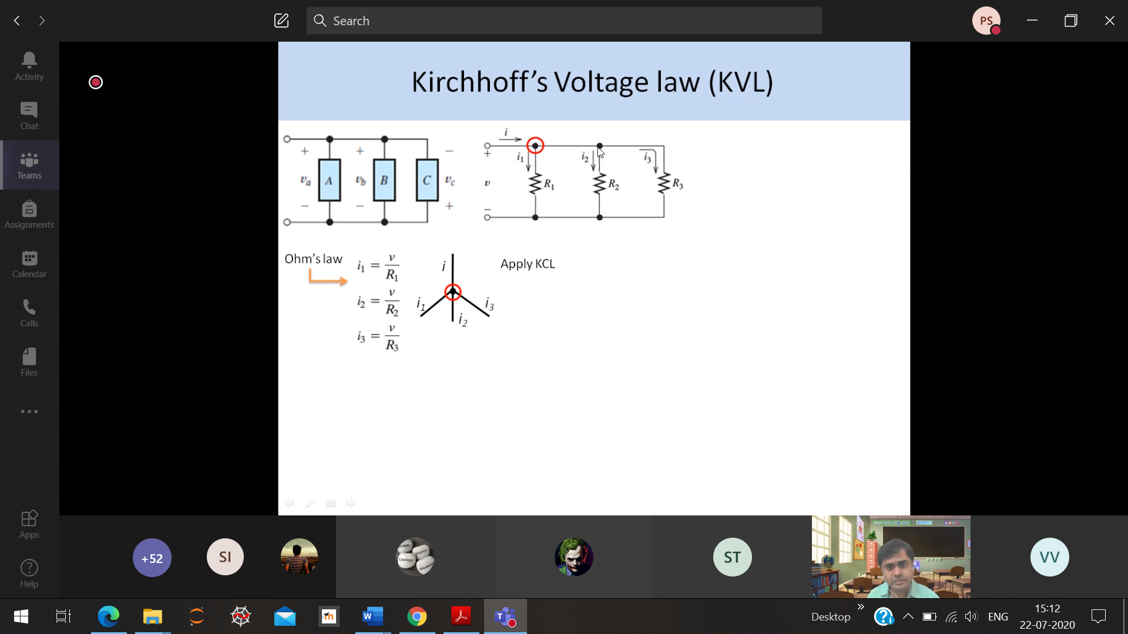

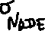

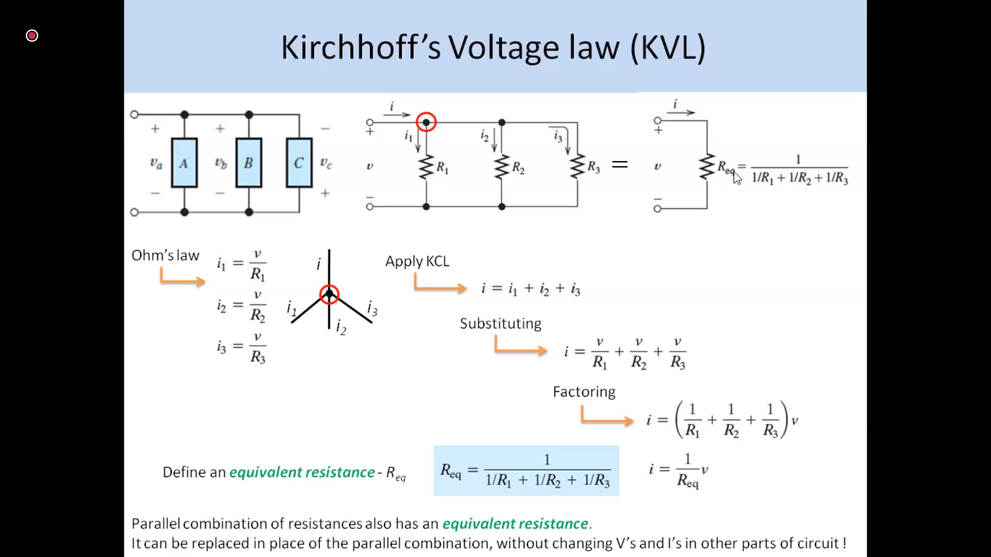

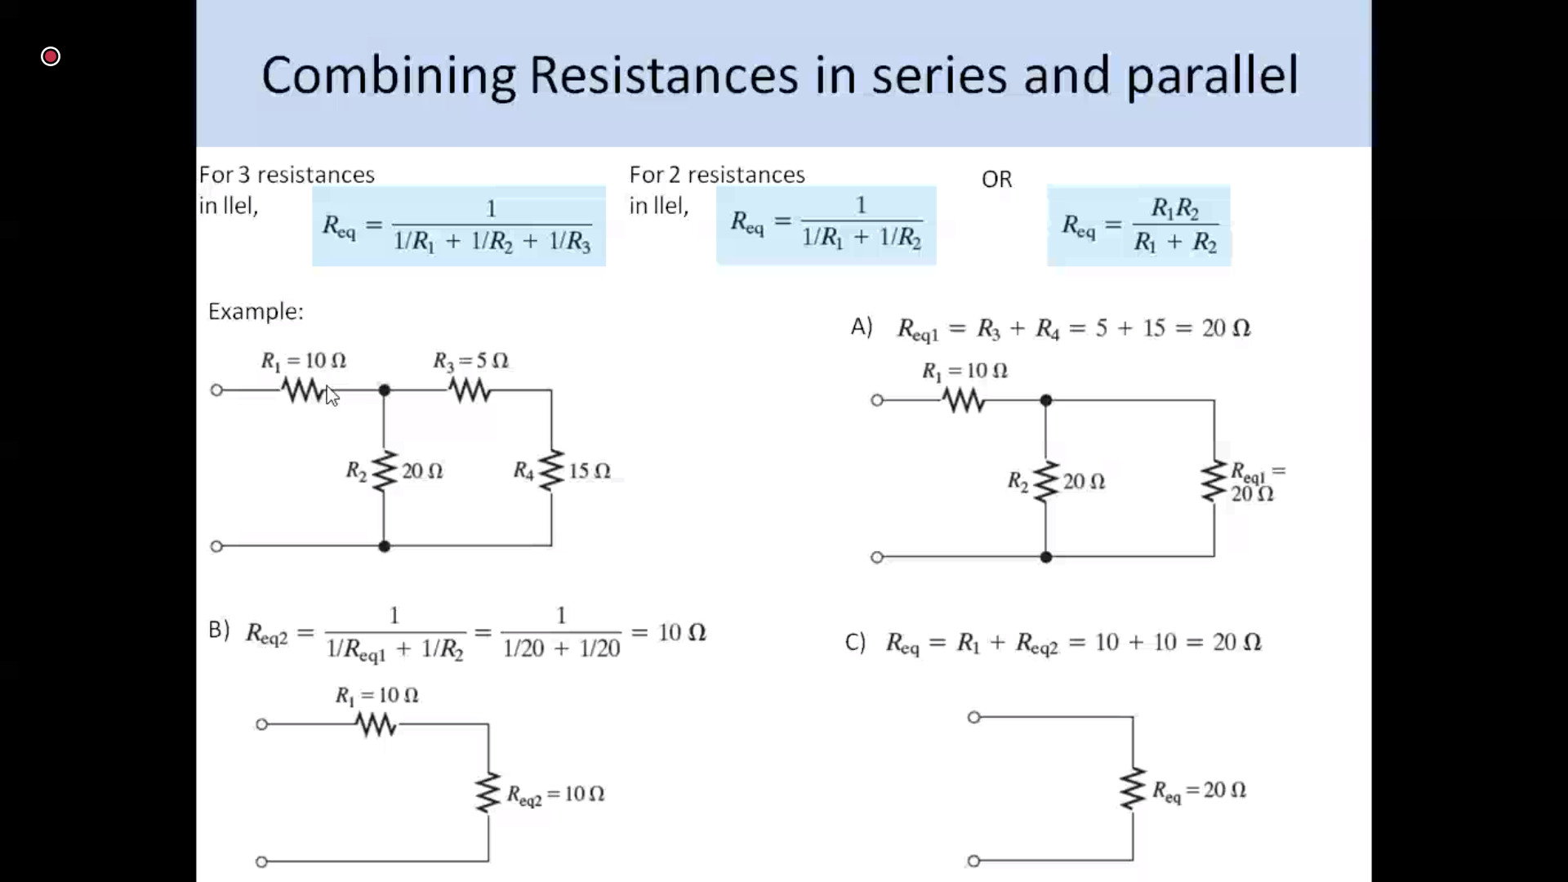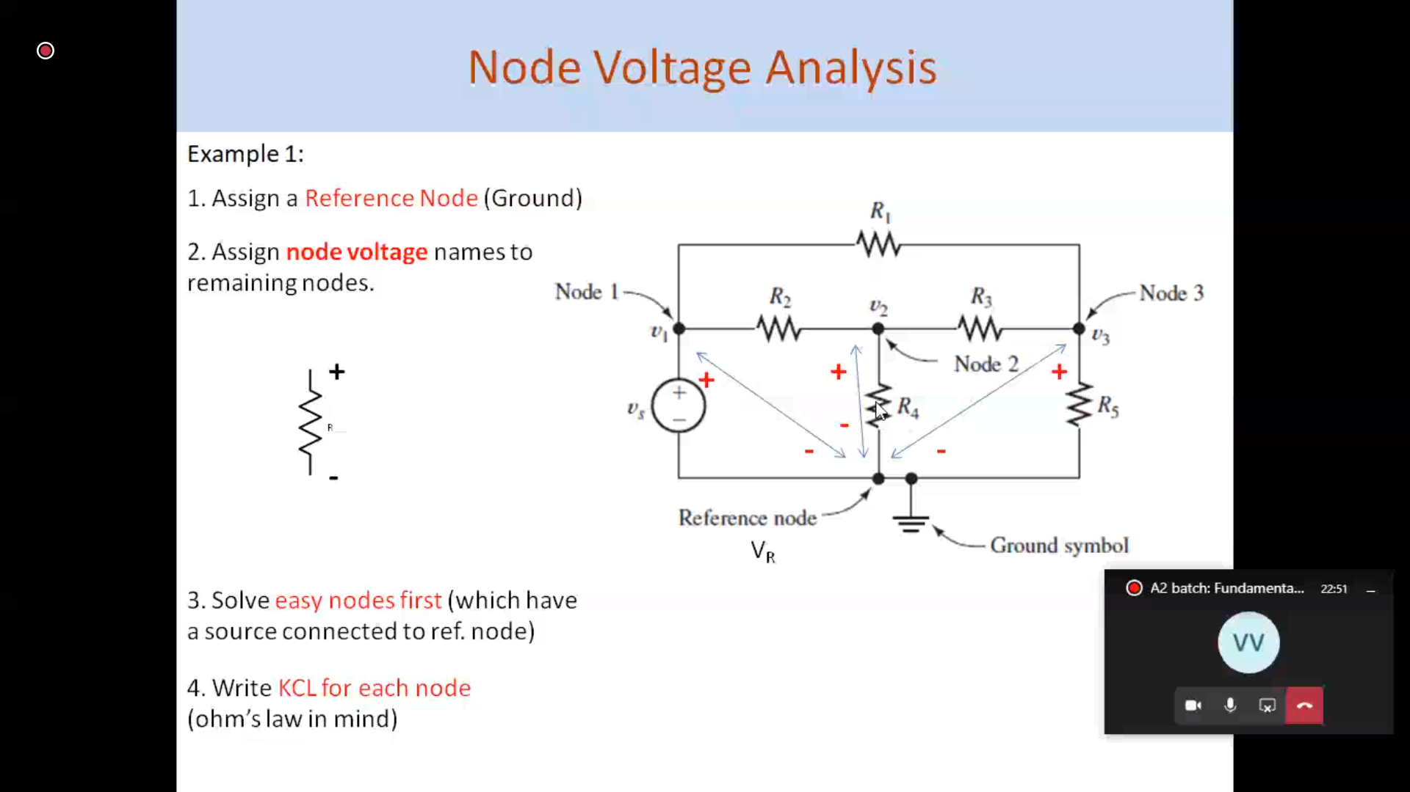

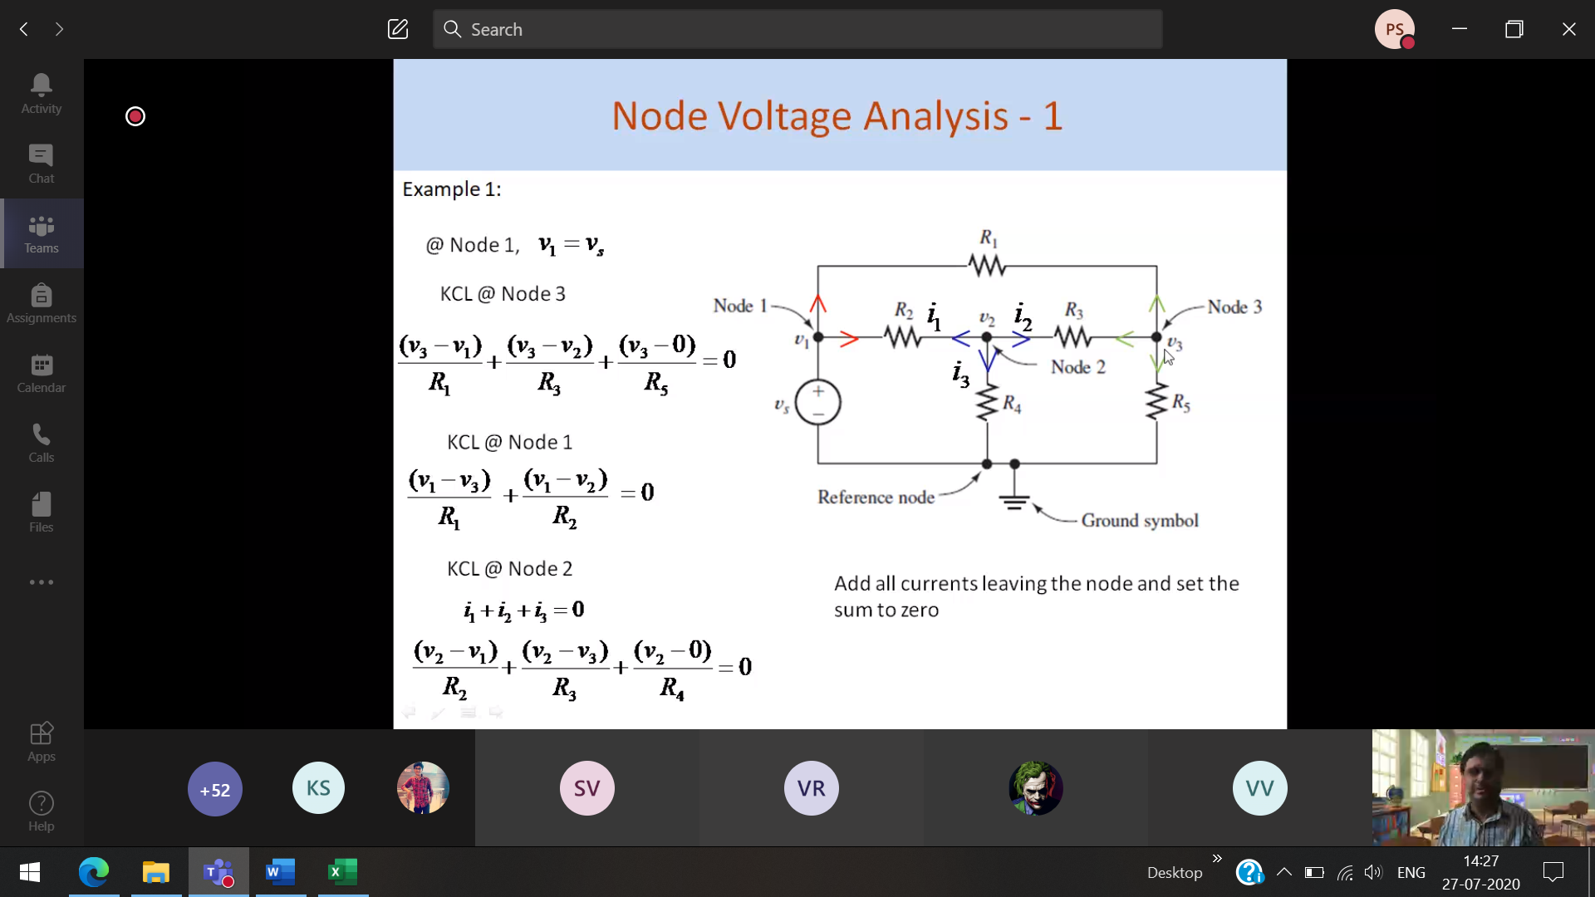

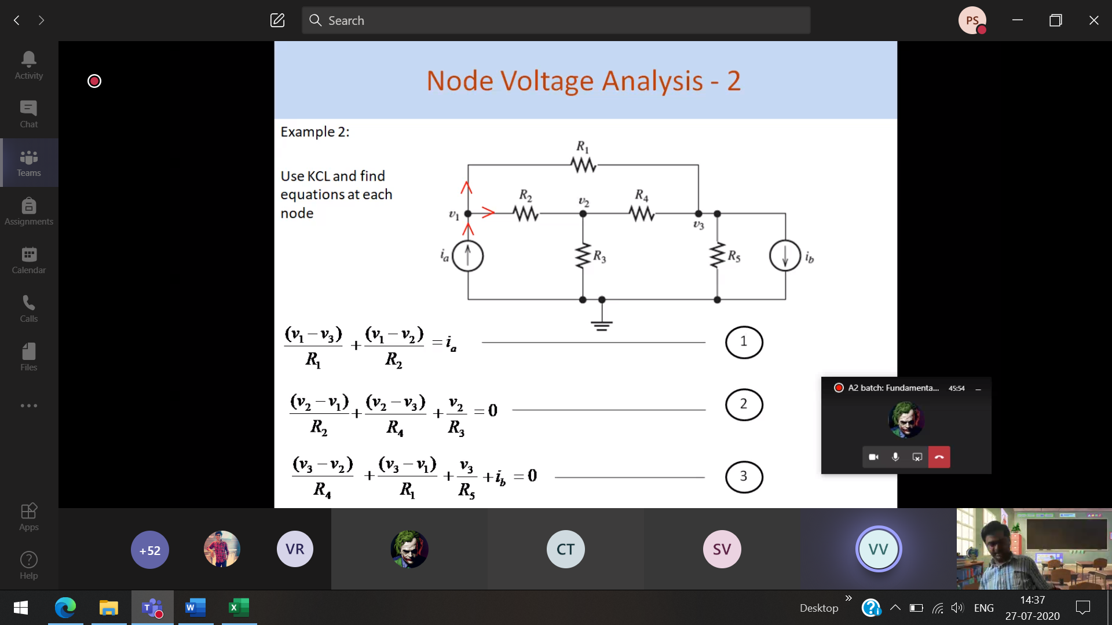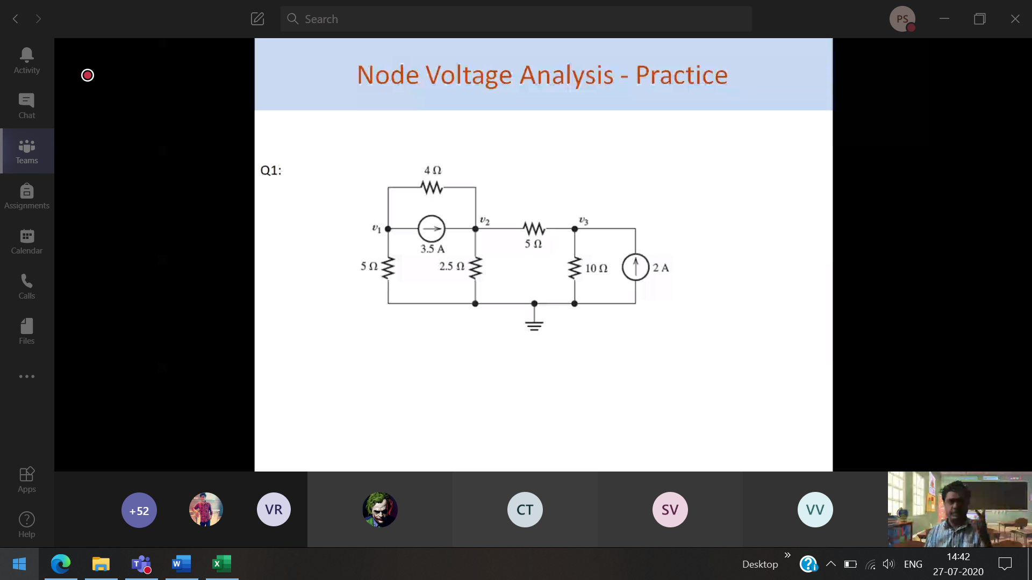

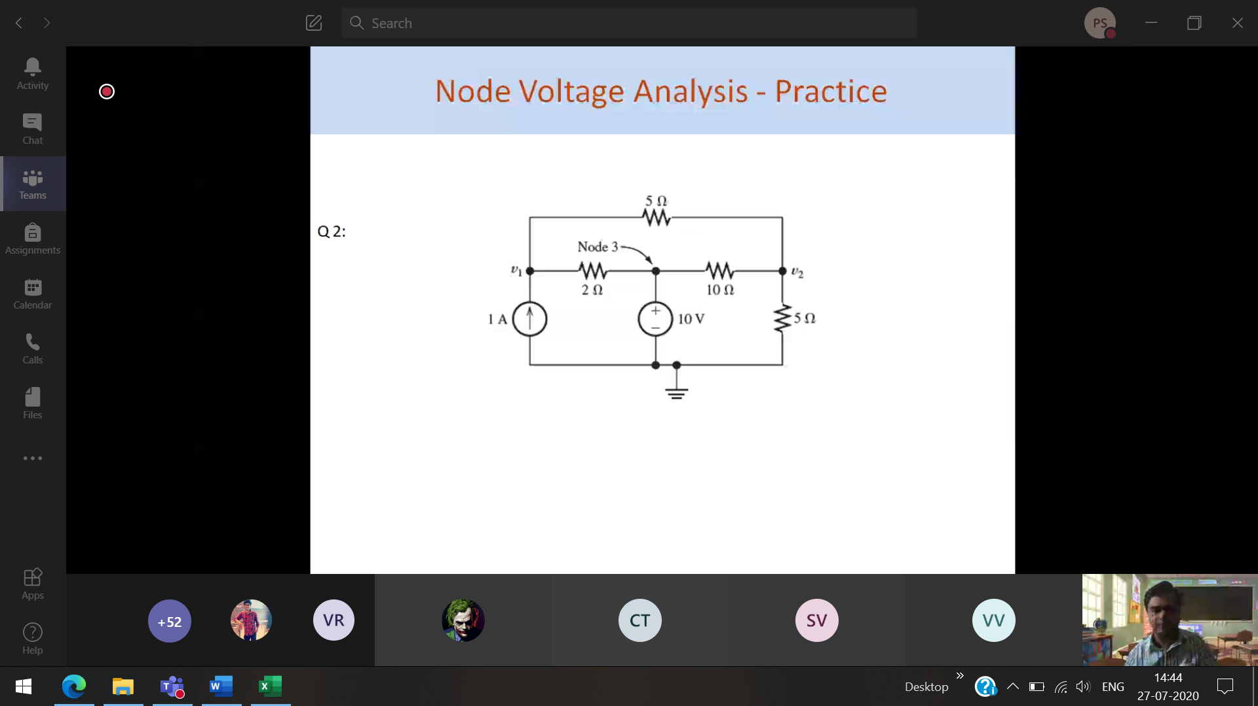

-5 5 10

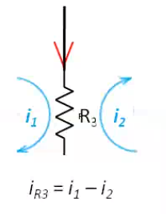

What is iR3???

Every mesh is independent

I am in mesh 1 🡪 that current is +ve, Other than that mesh all the current is -ve

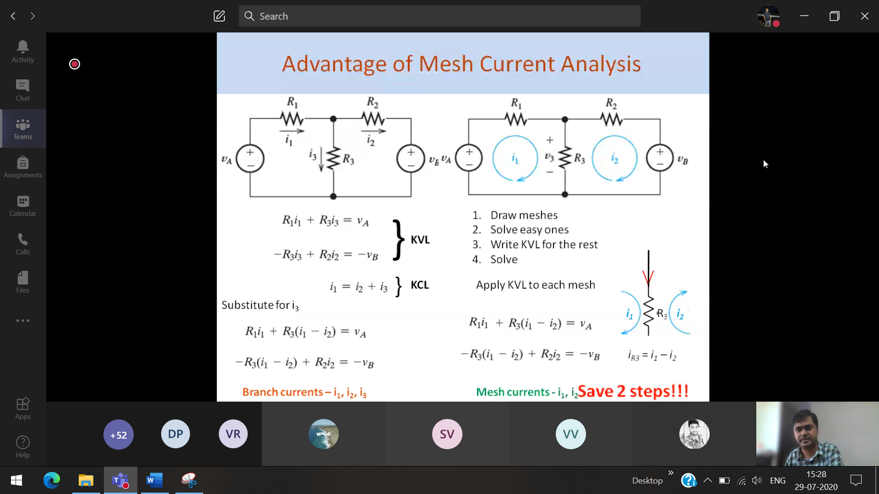

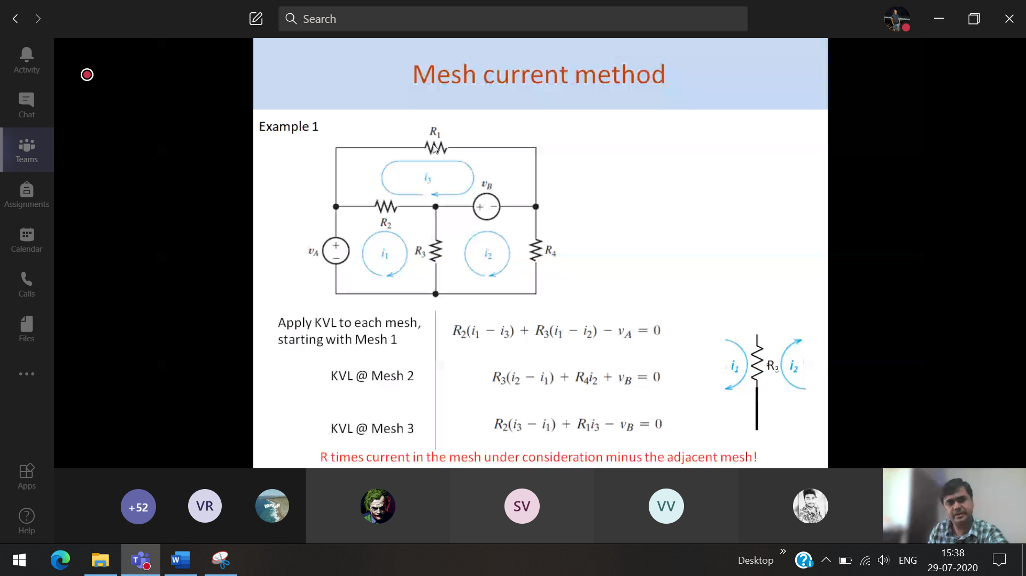

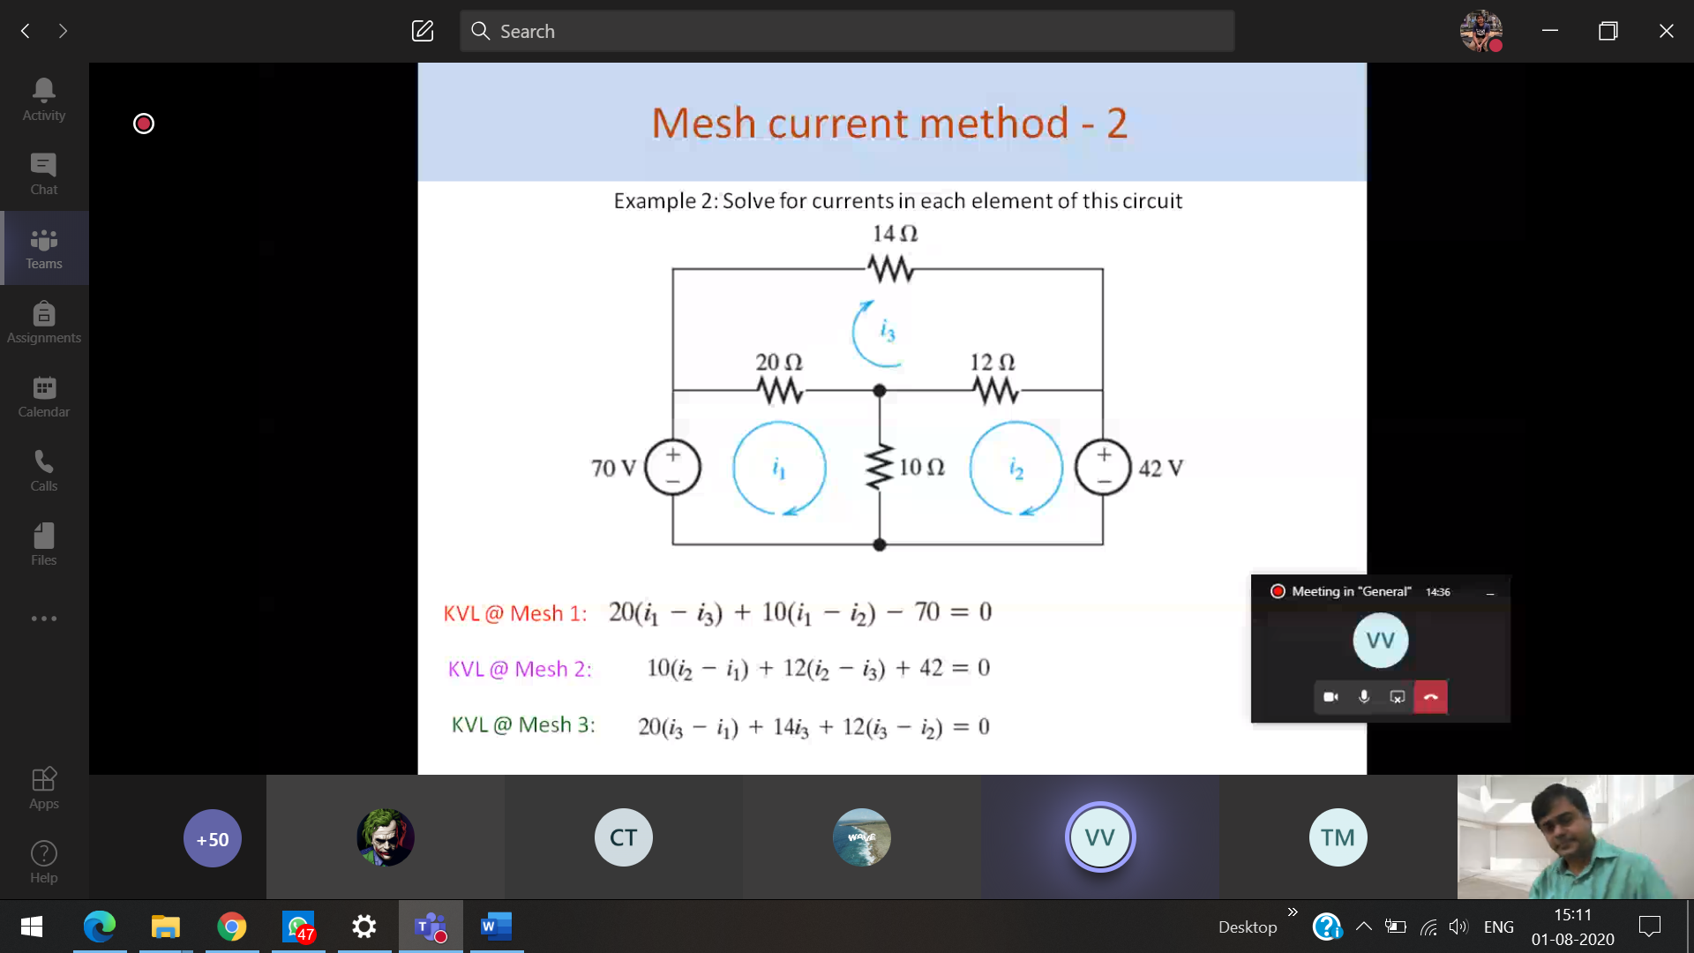

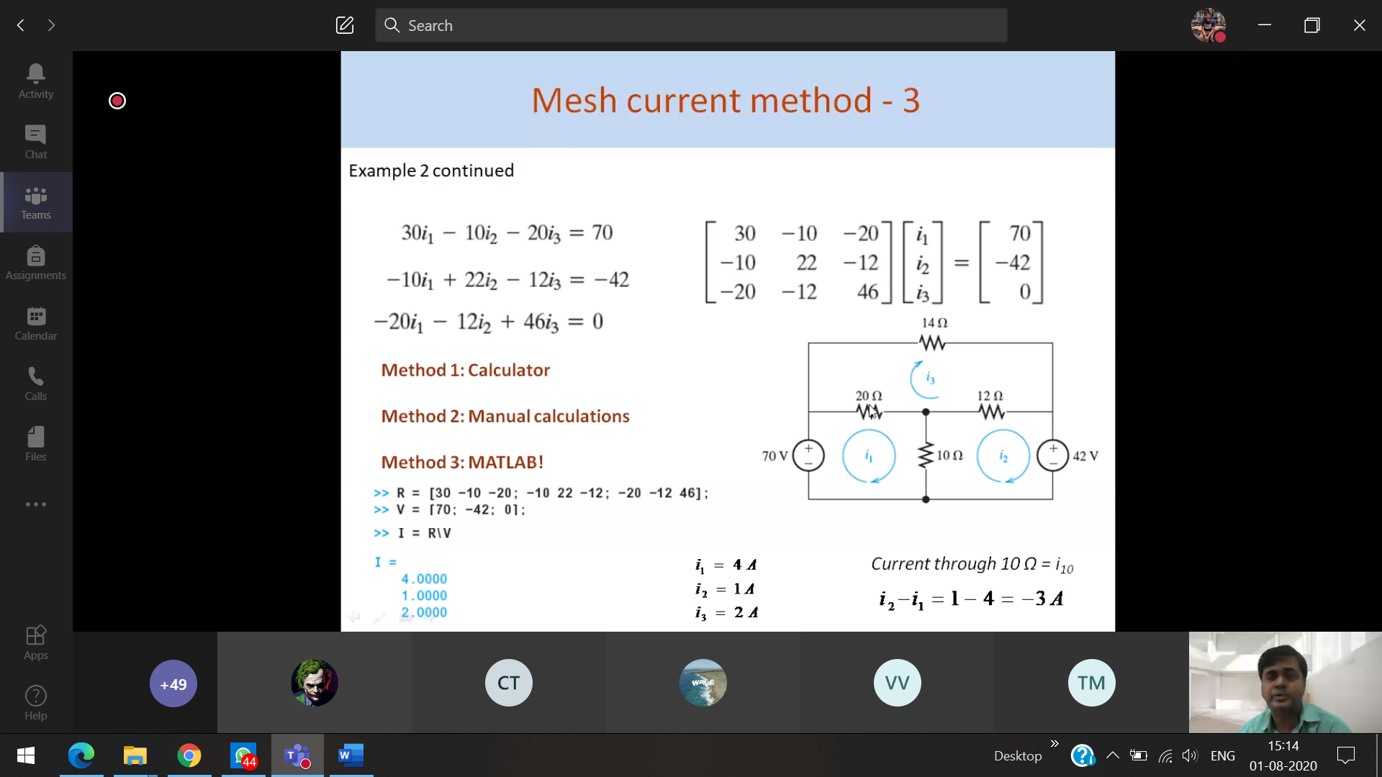

I 10 is a branch current



i1 – i2 🡪 3A



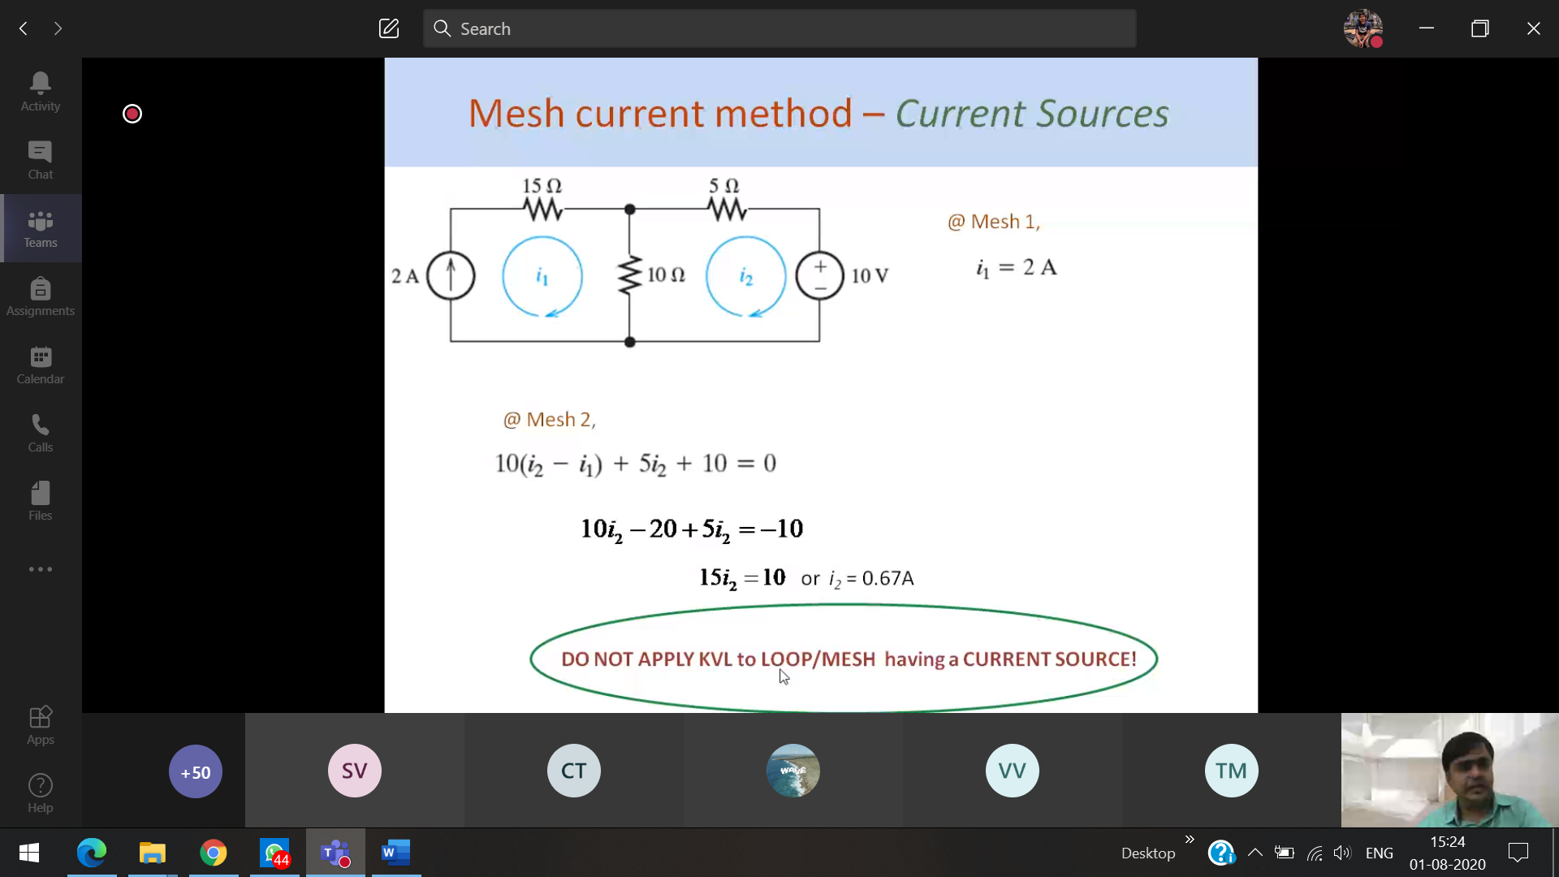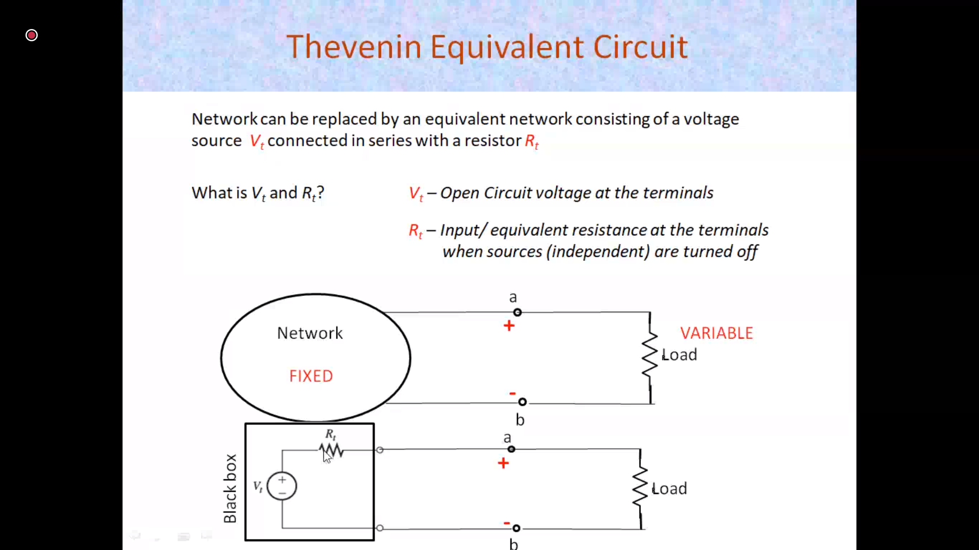

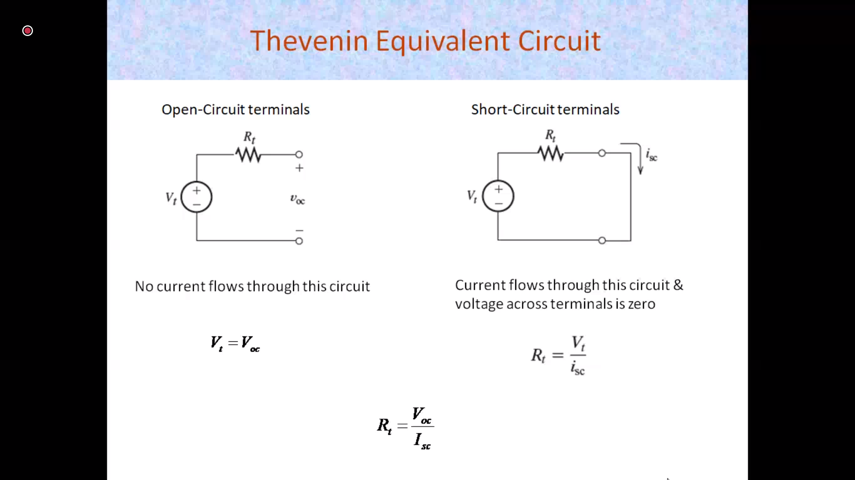

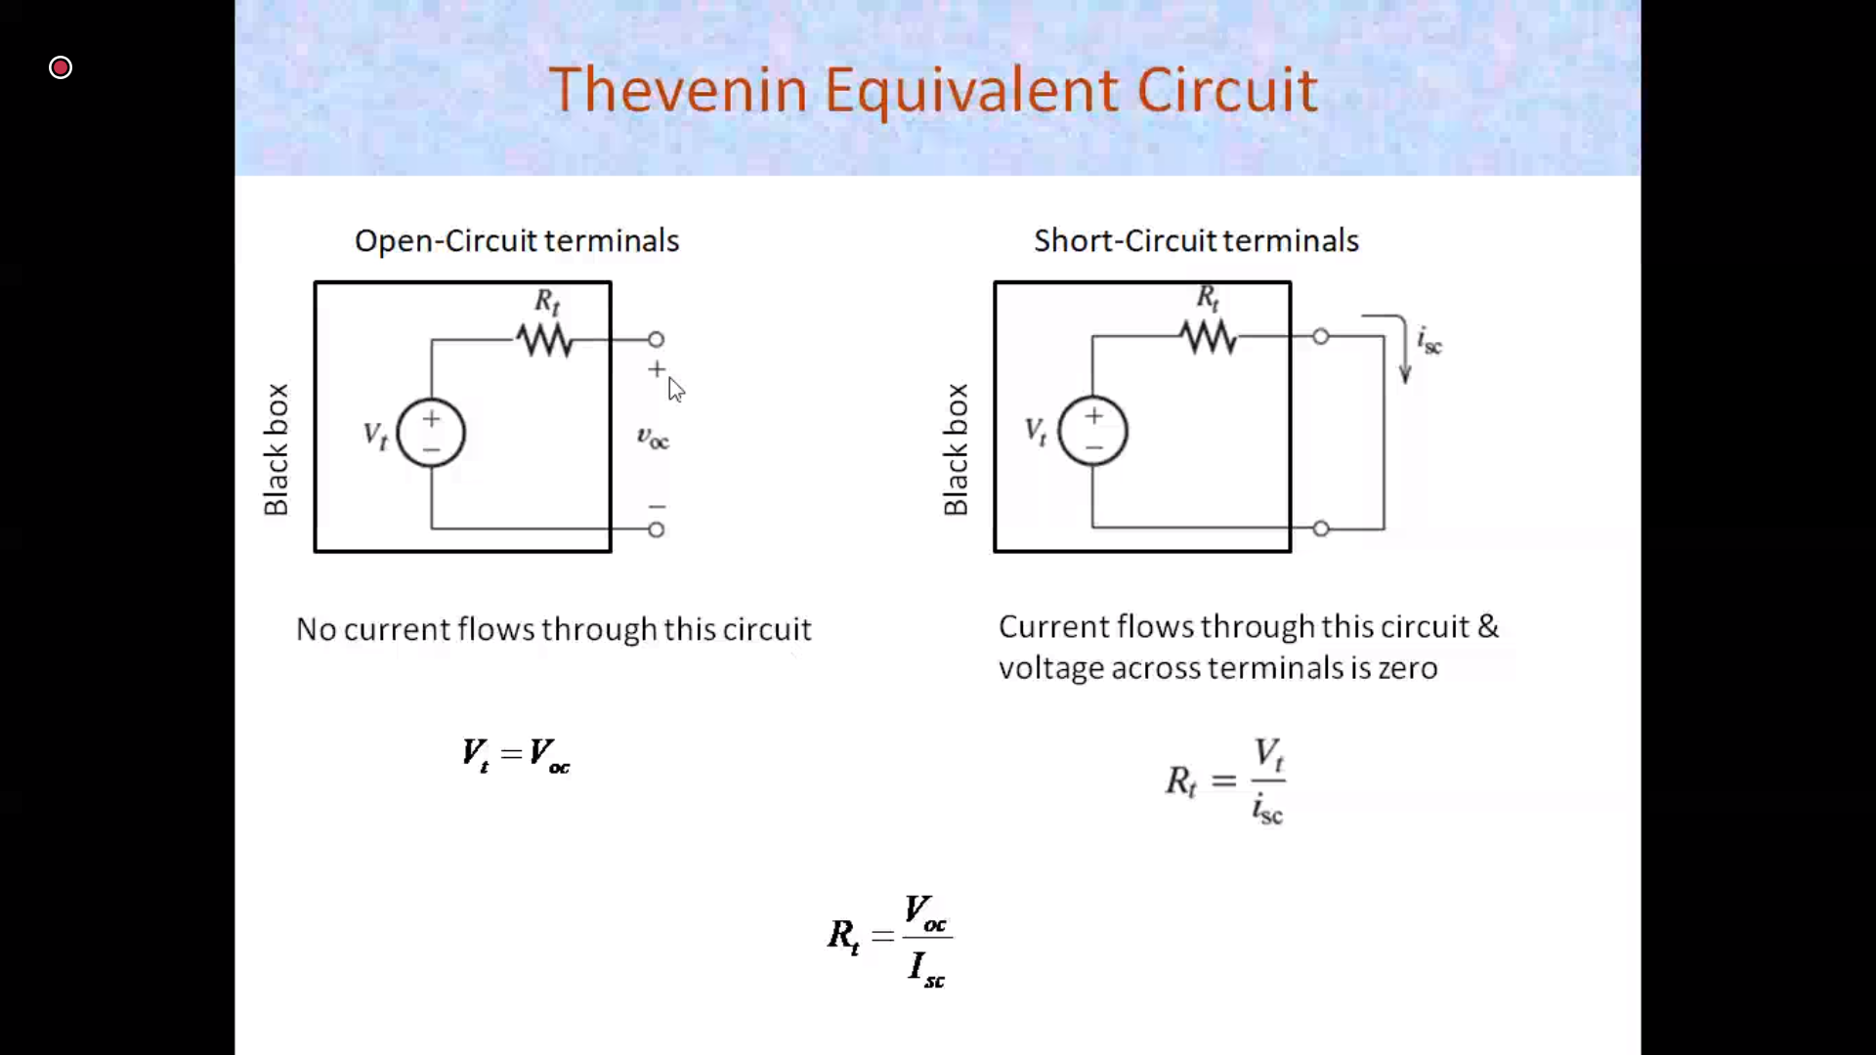

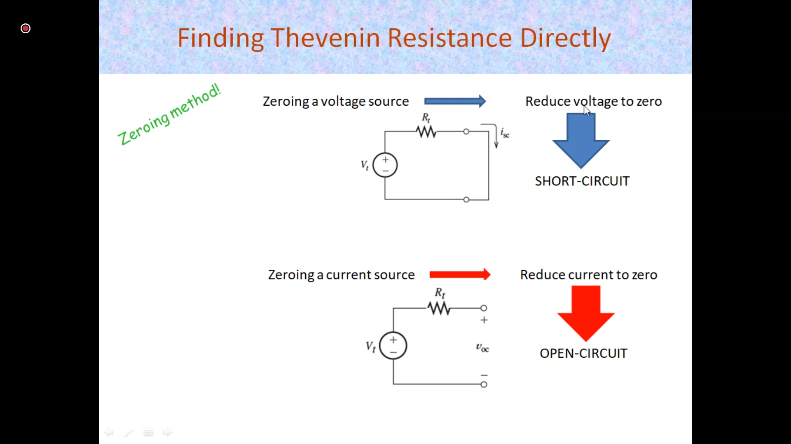



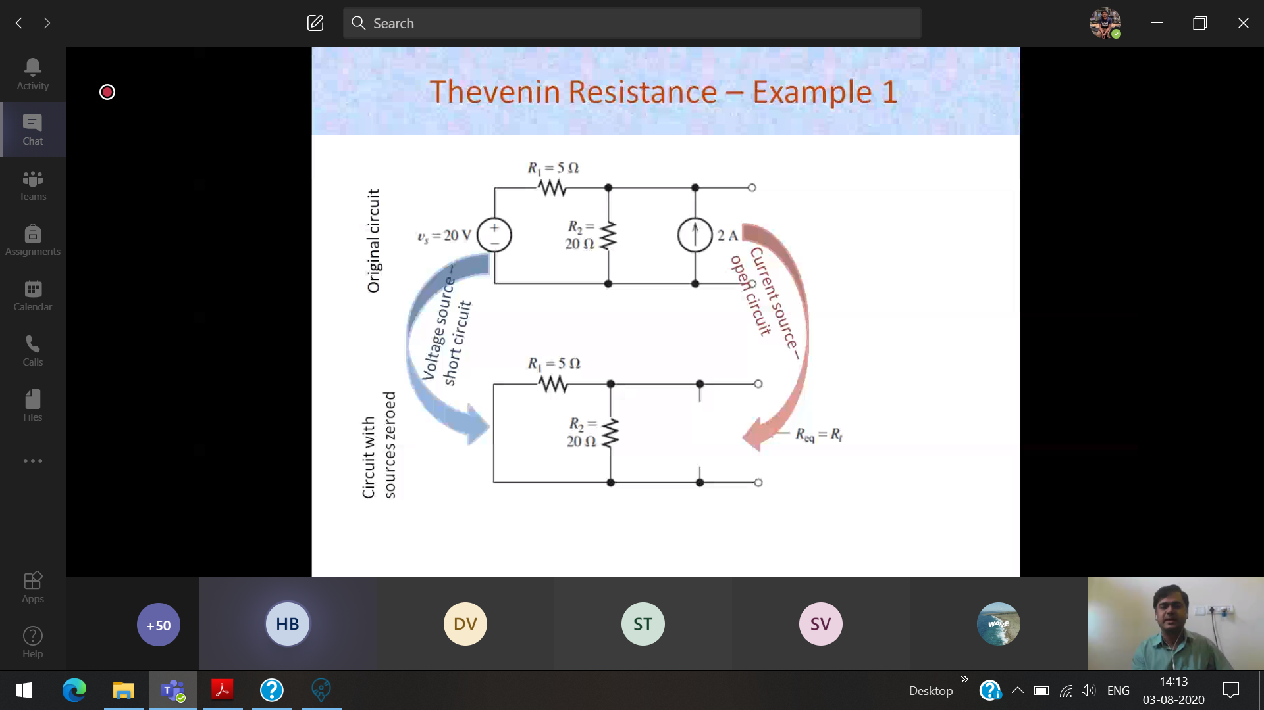

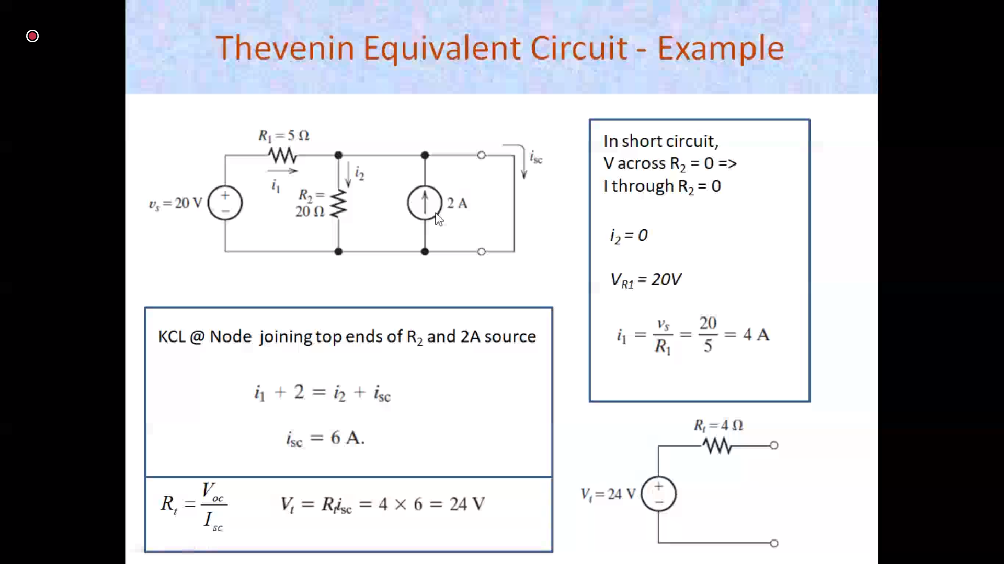



Can do the same sum without calculating the isc

20-v1 - v1 + 2 = 0



5 20

**Both are one node**

**Due to short circuiting, current will flow through the least resistance path, ic**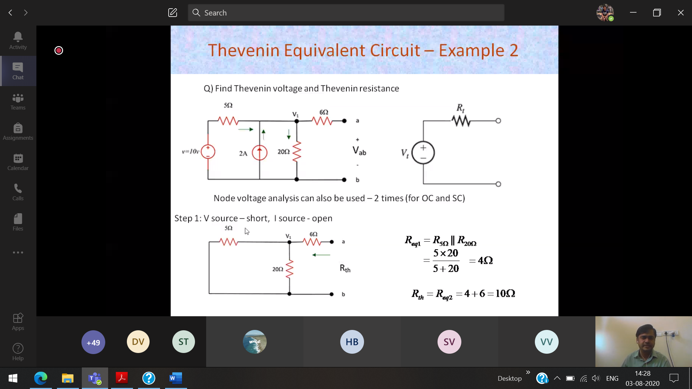

**Open circuit voltage 🡪 Thevenin voltage**

**Voltage to 0 🡪 short circuit**

**Current to 0 🡪 open circuit**

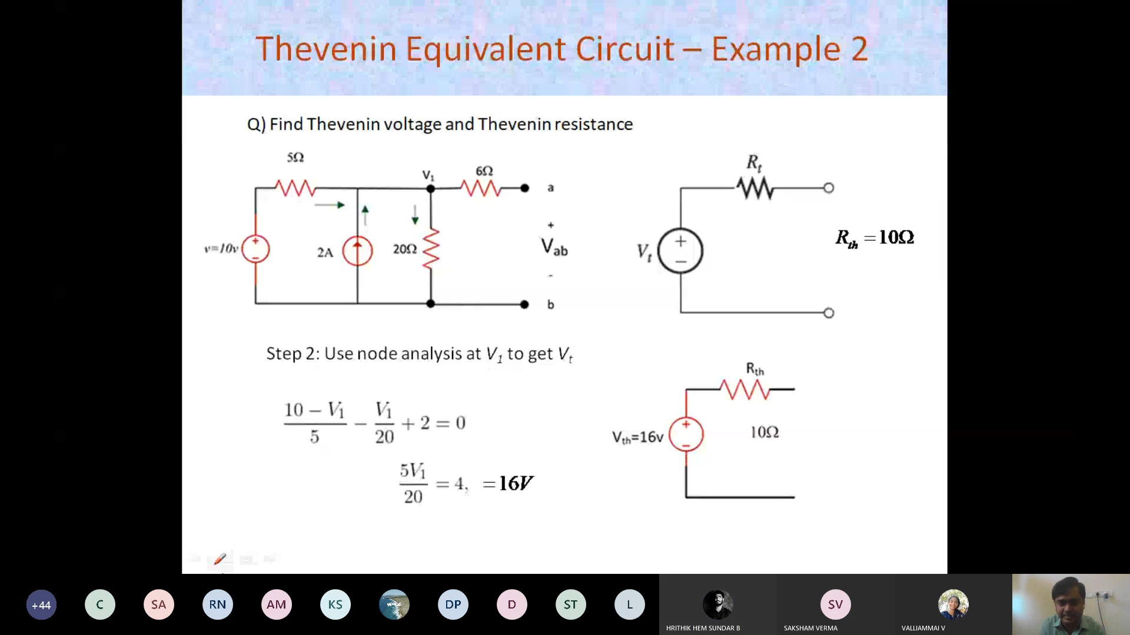

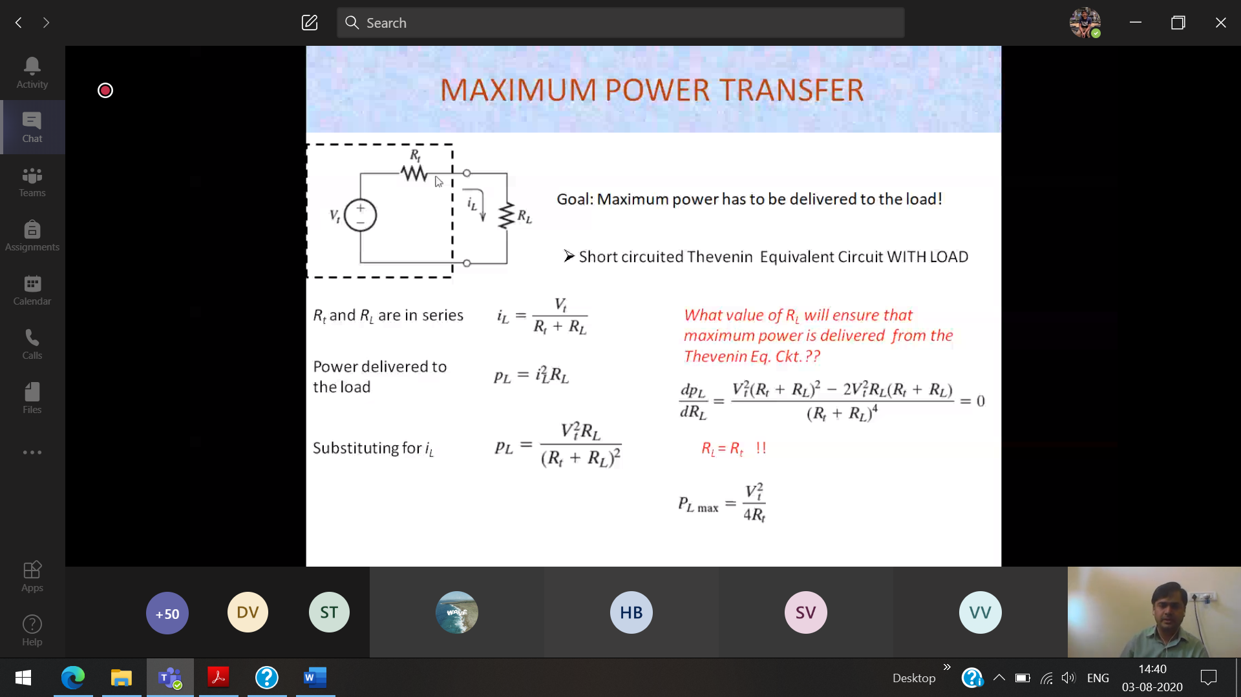

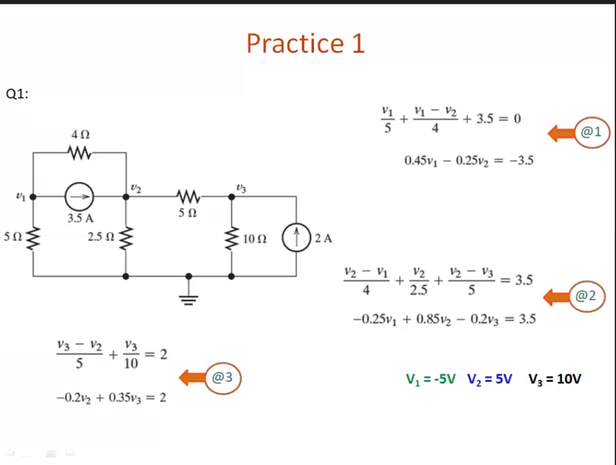



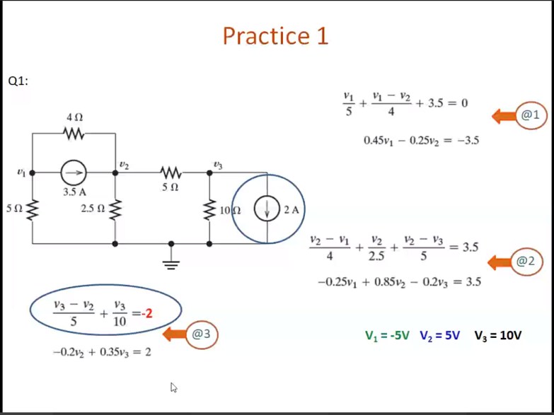

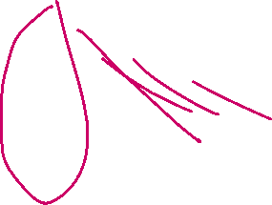

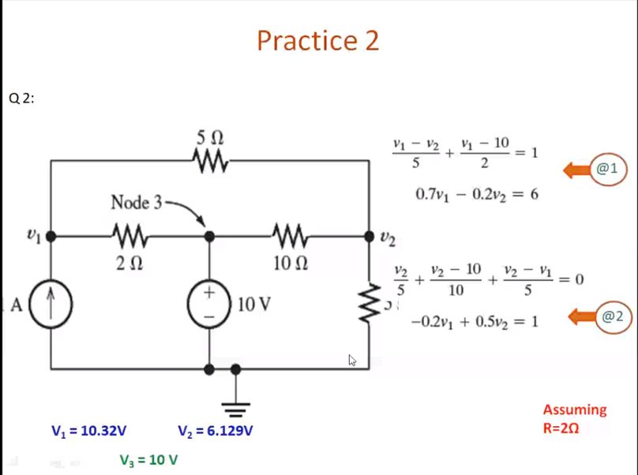



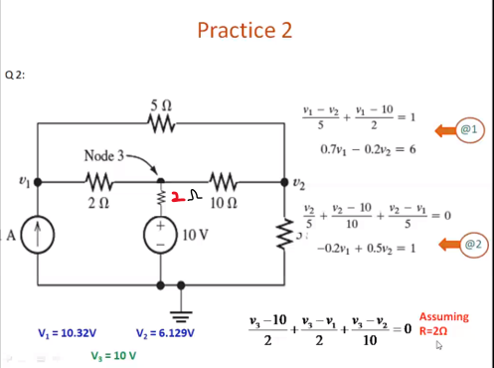



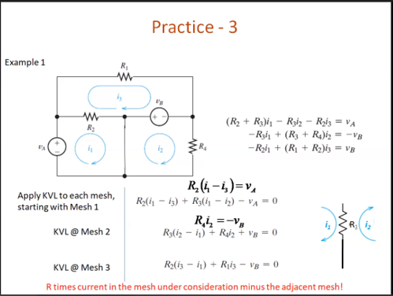

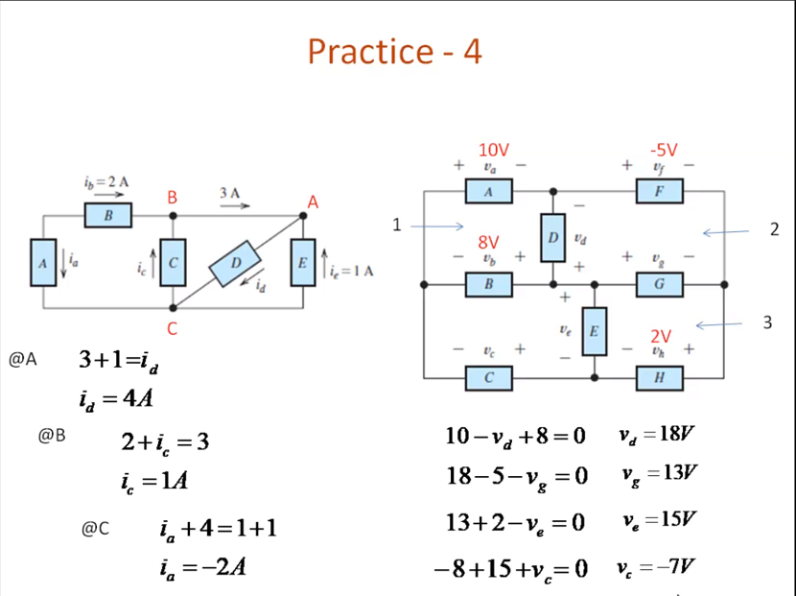



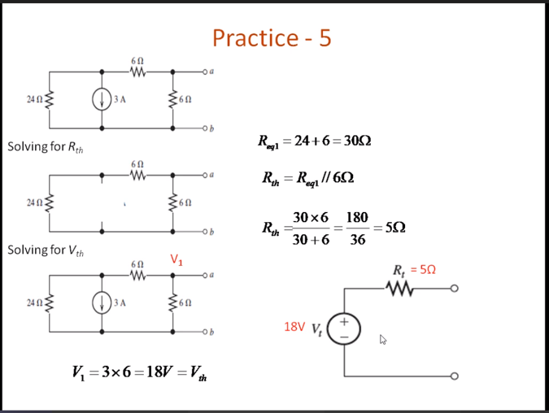

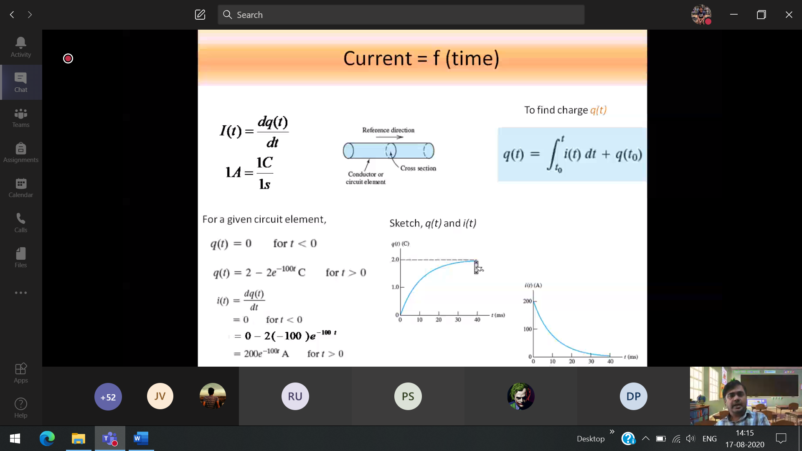

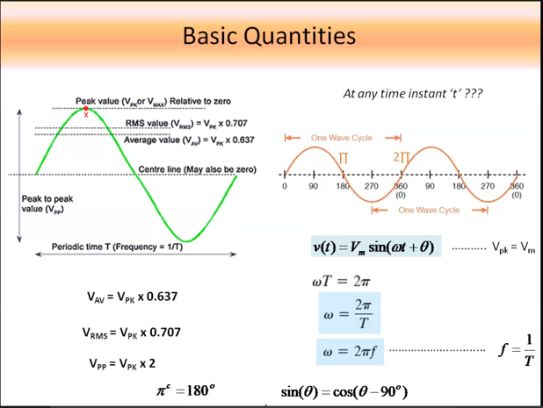

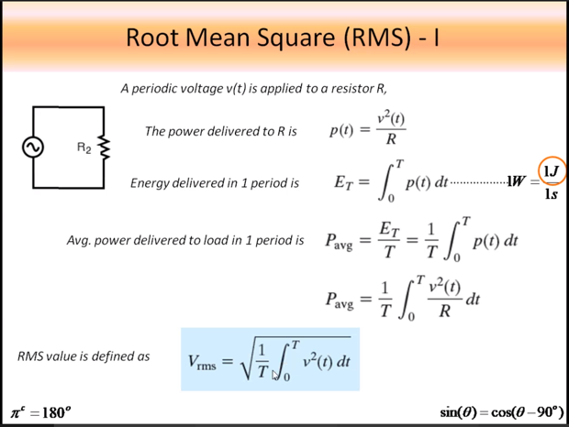

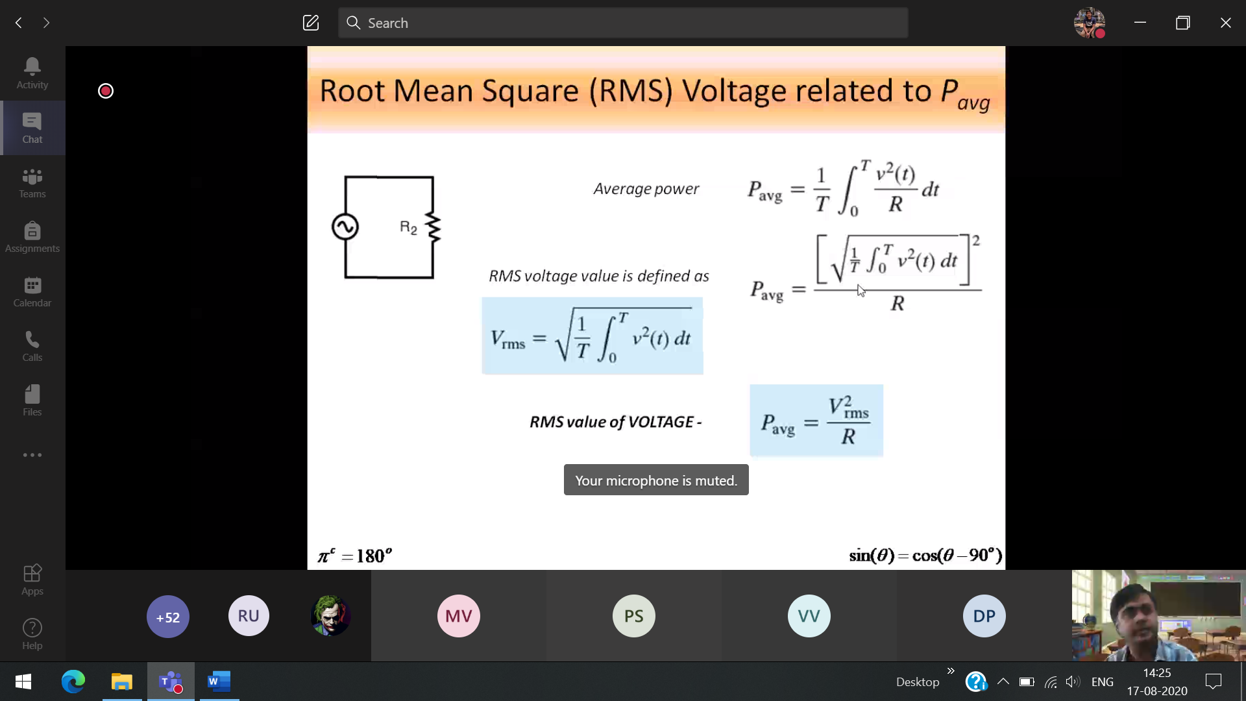

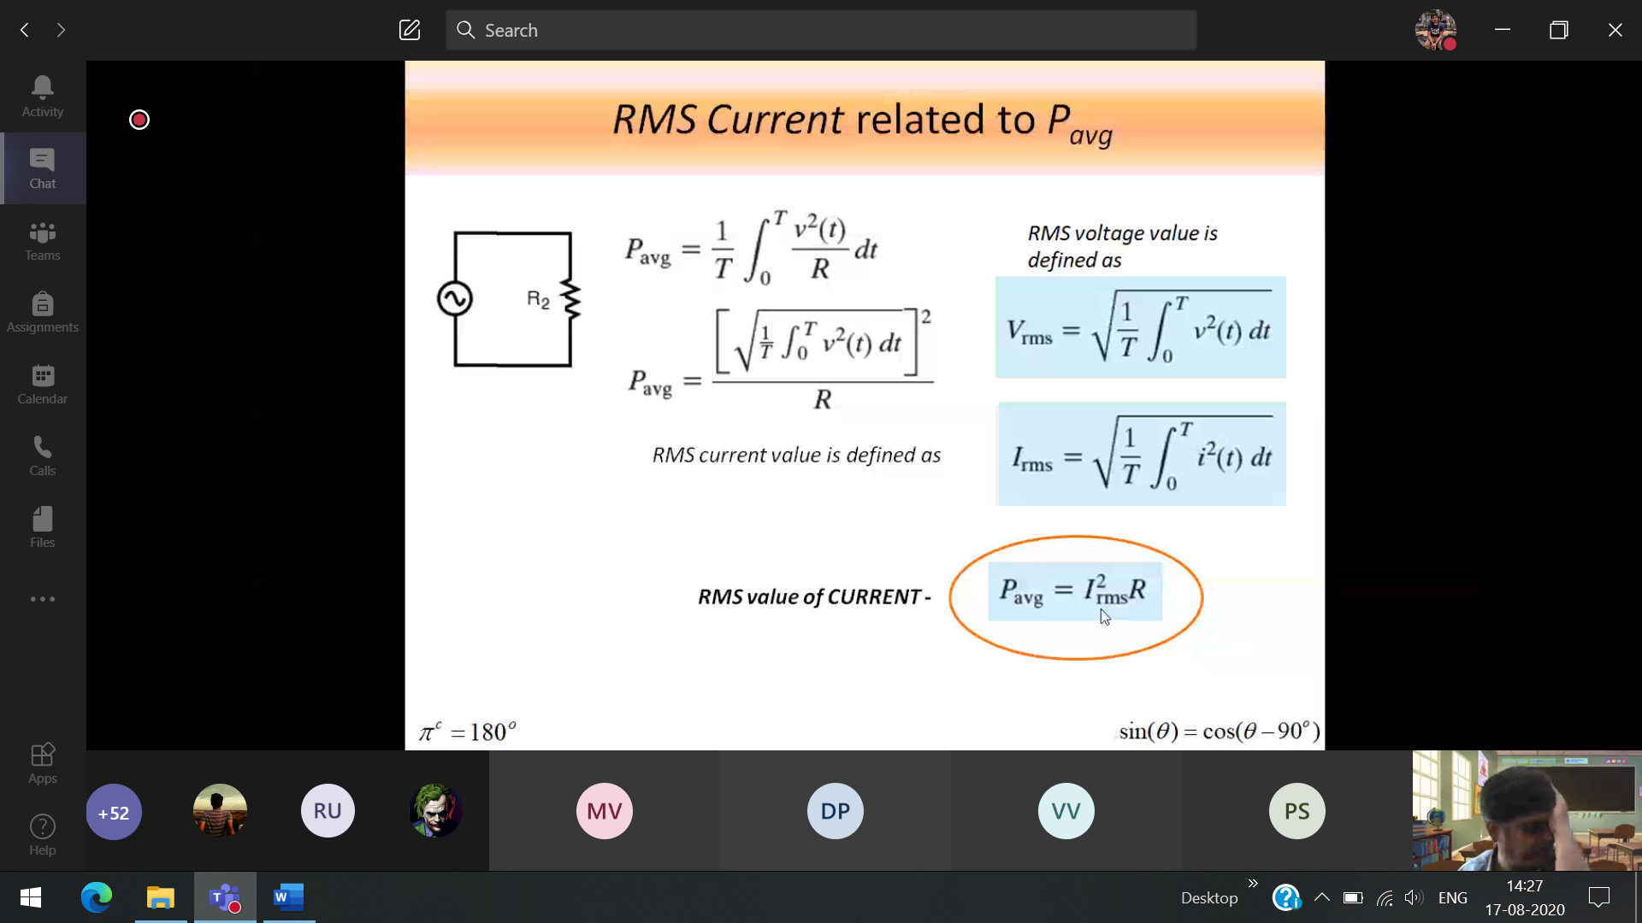

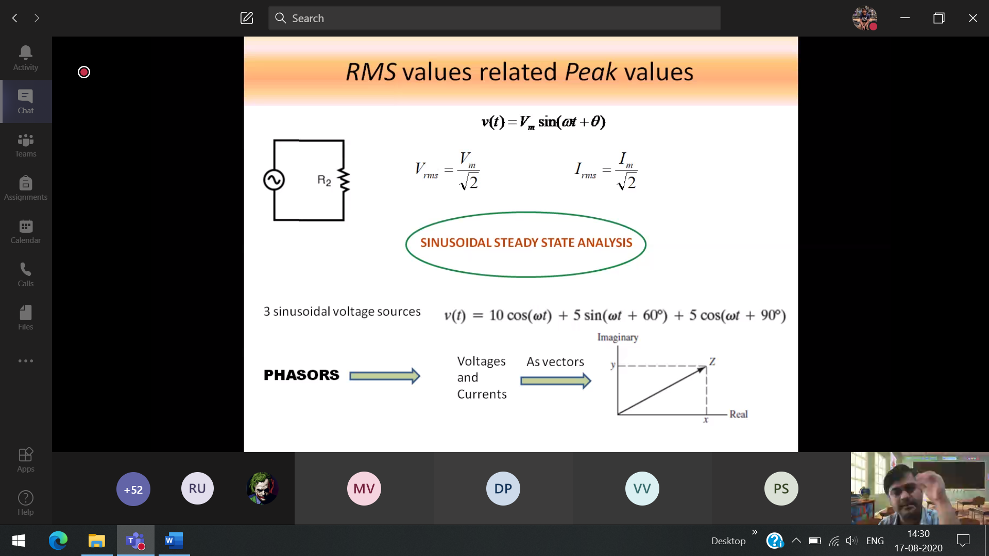

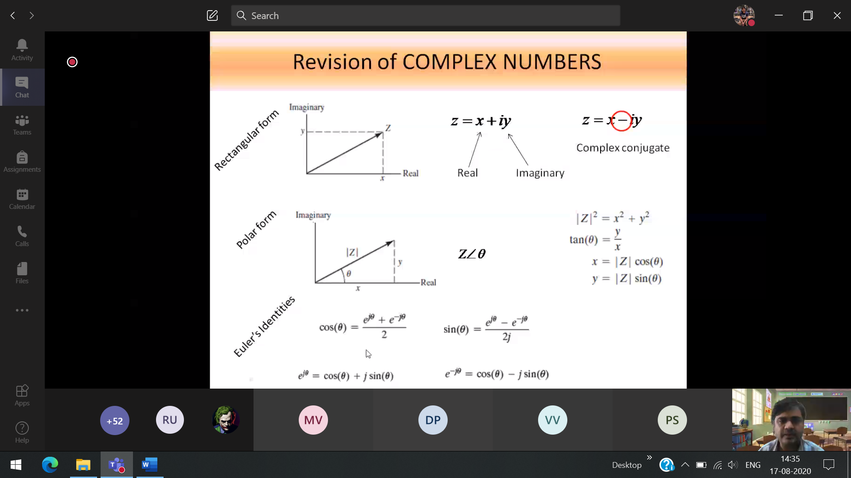

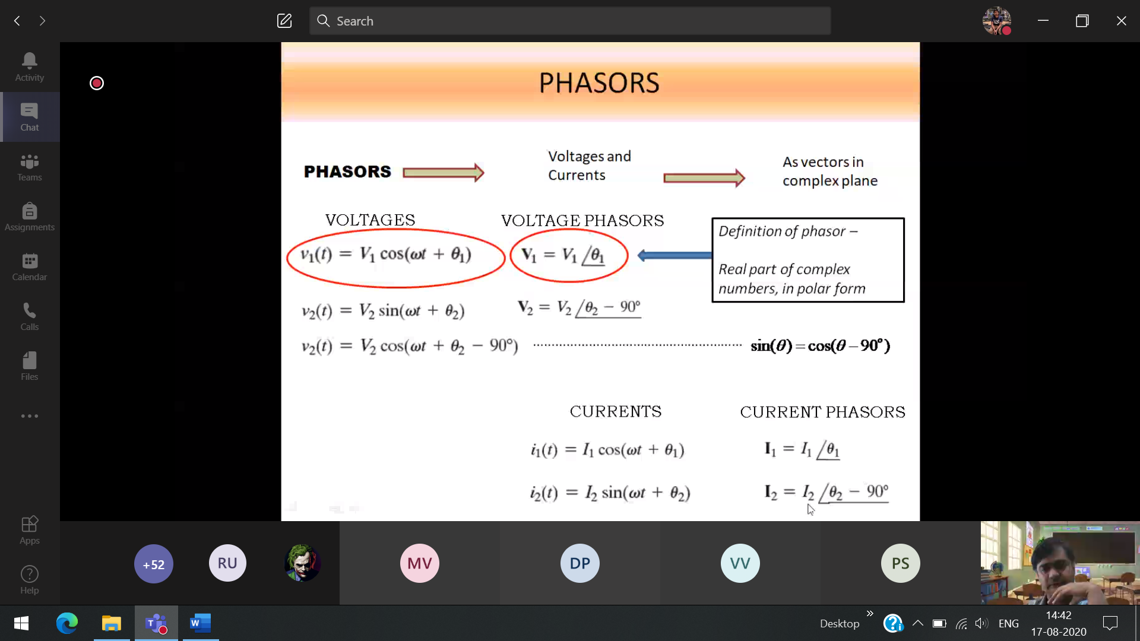

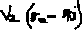

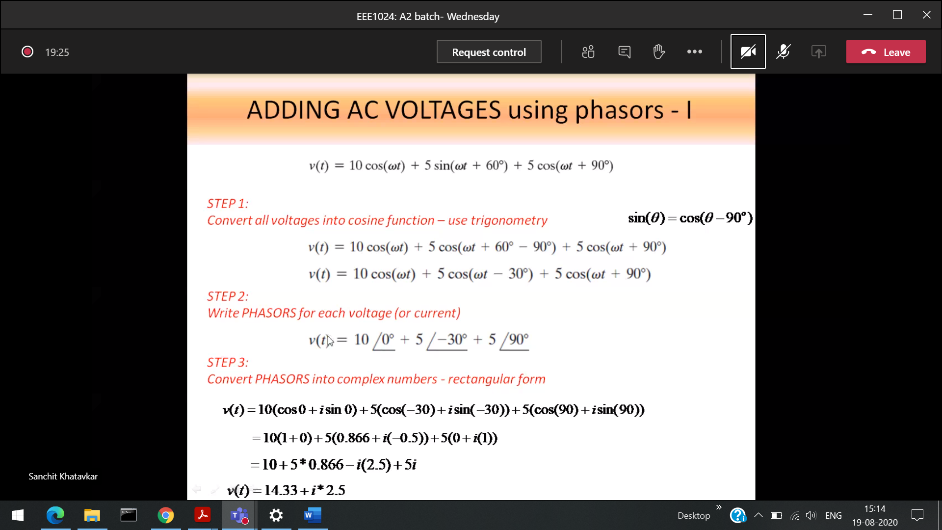

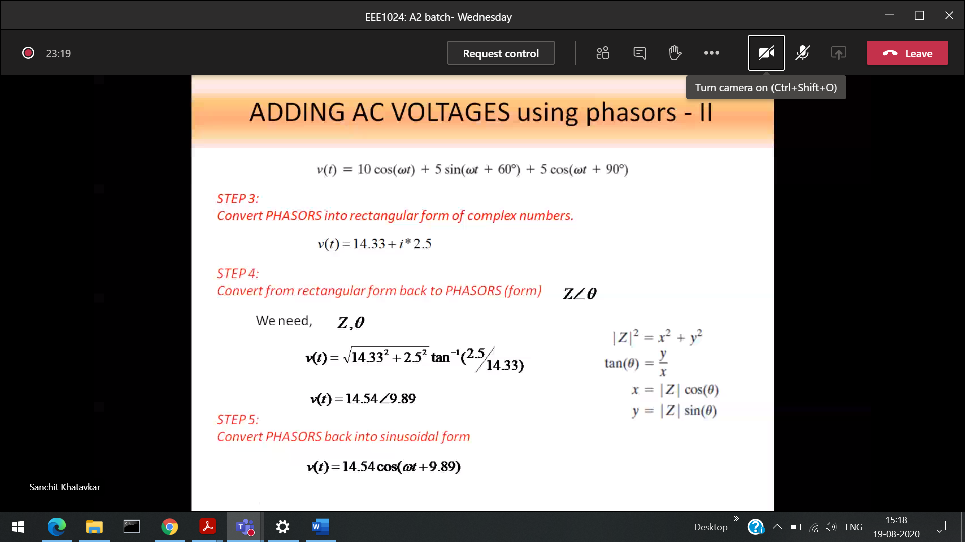

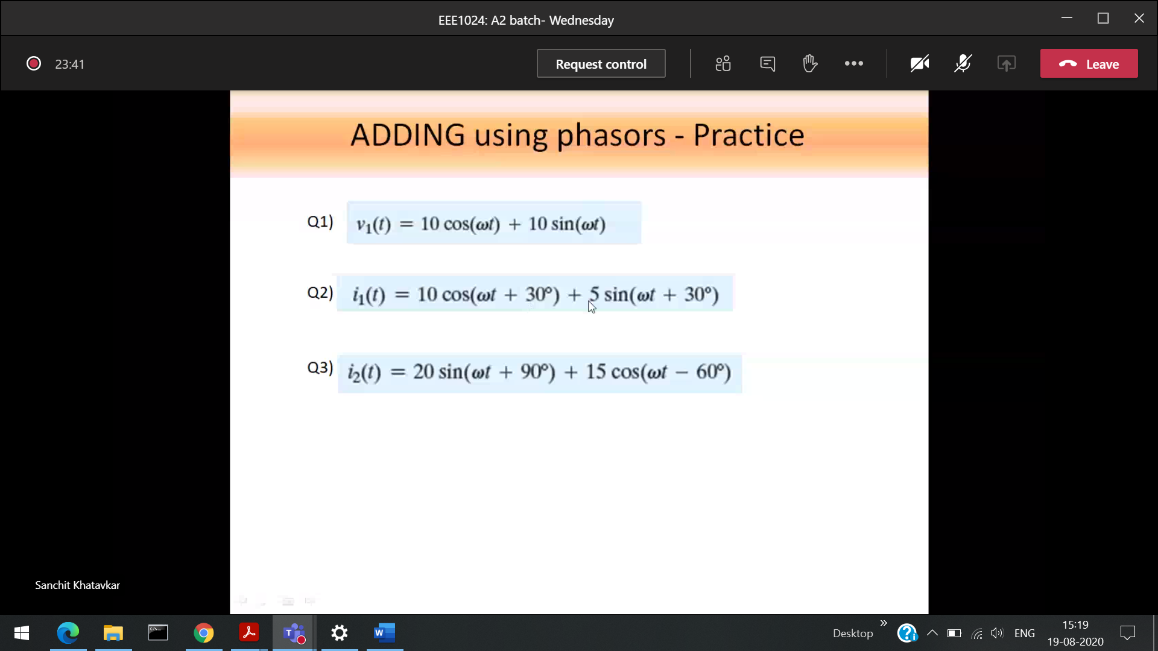

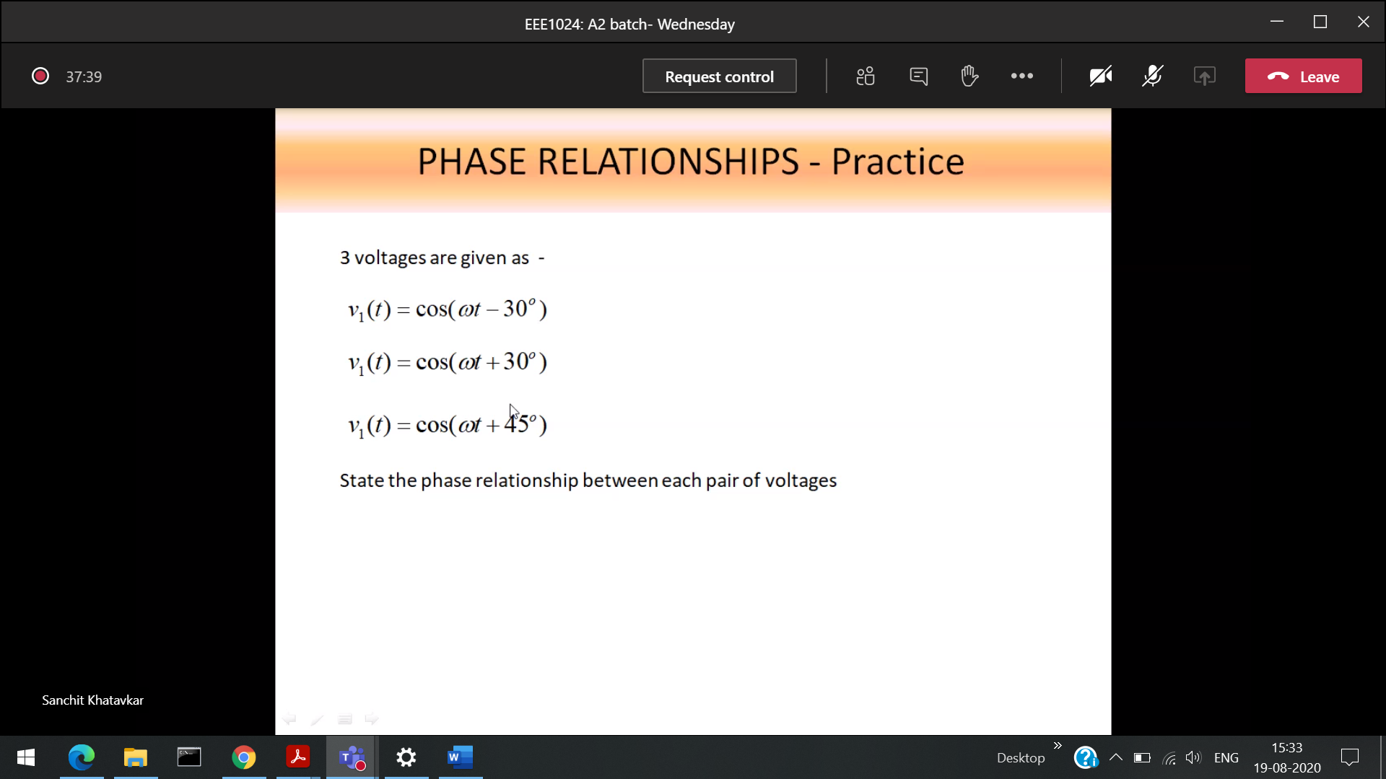

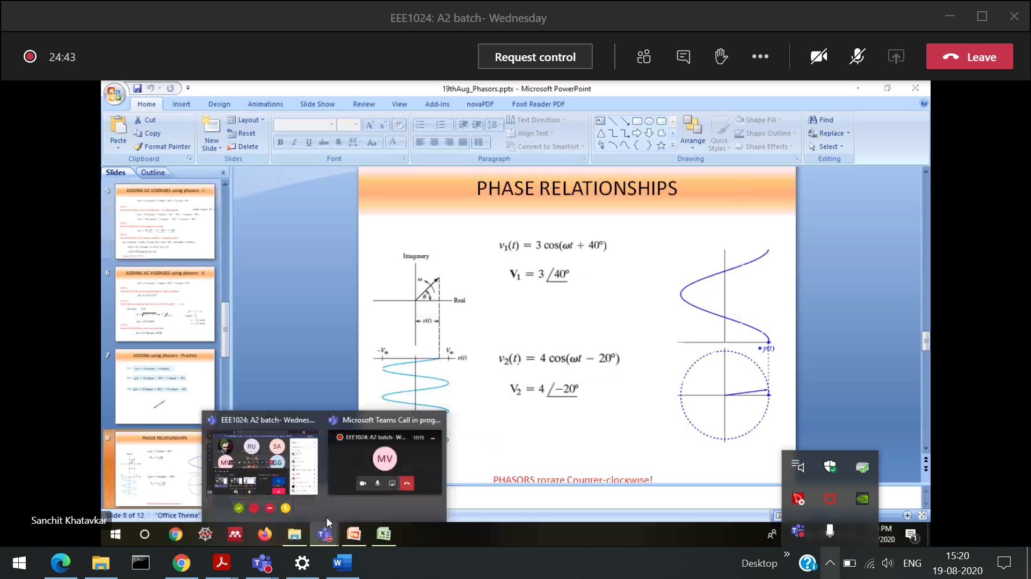

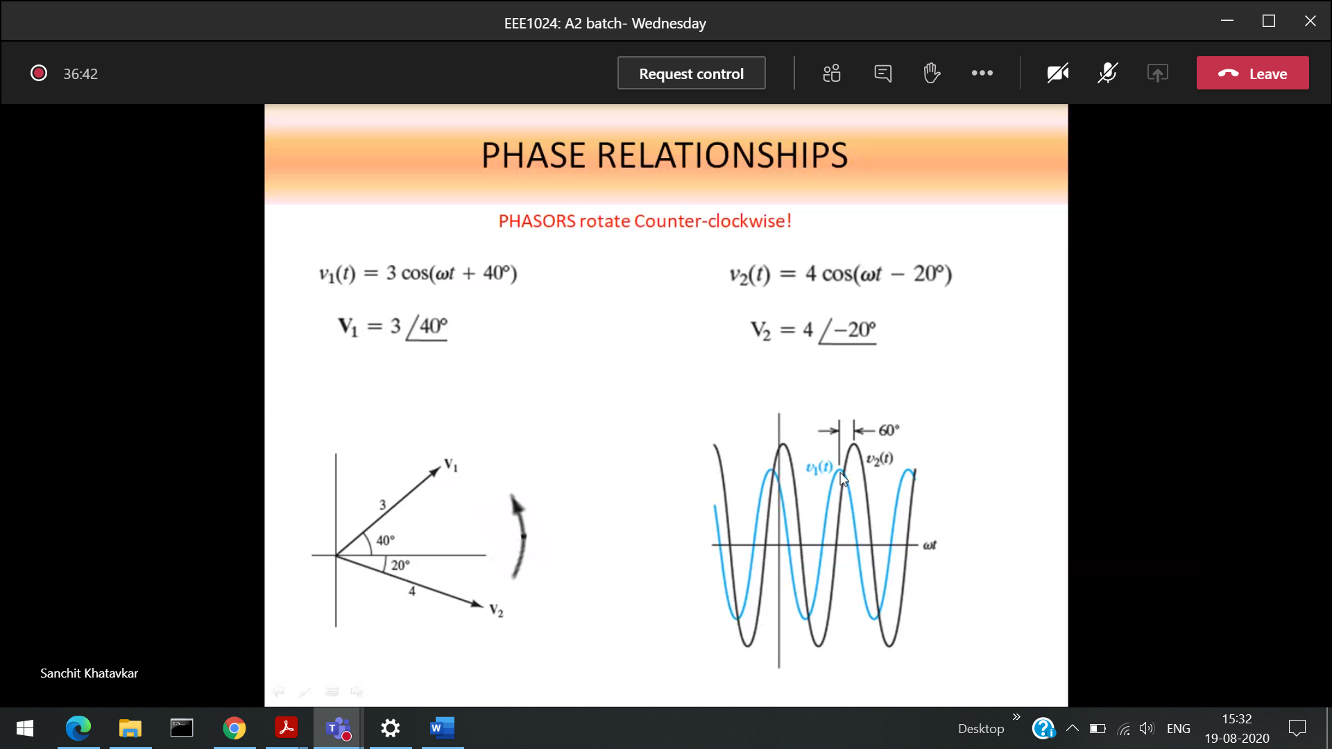

**V2 leads v1 by 60**

**V1 lags v2 by 60**

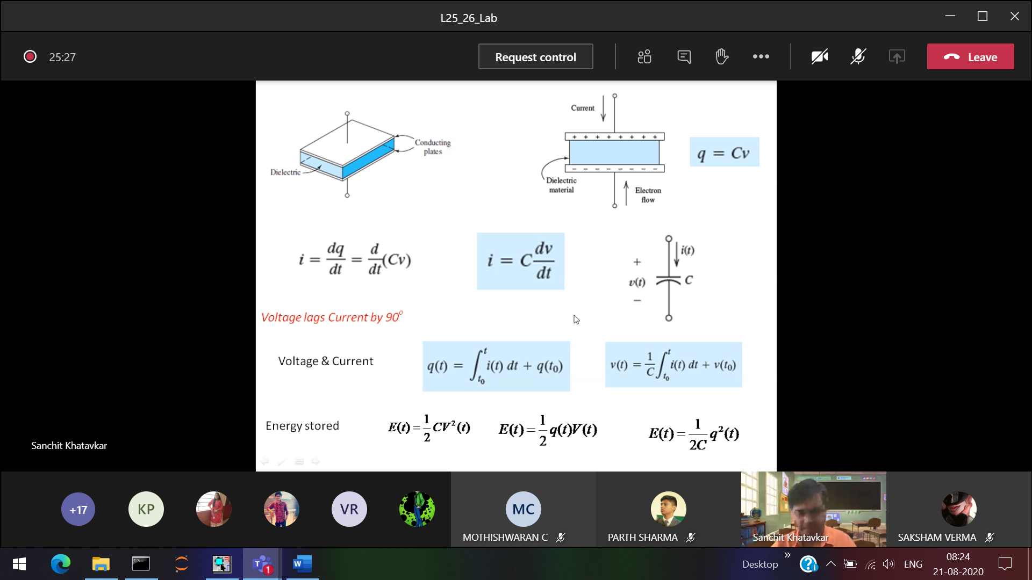

**Inductor 🡪 stores the energy in the form of magnetic field**

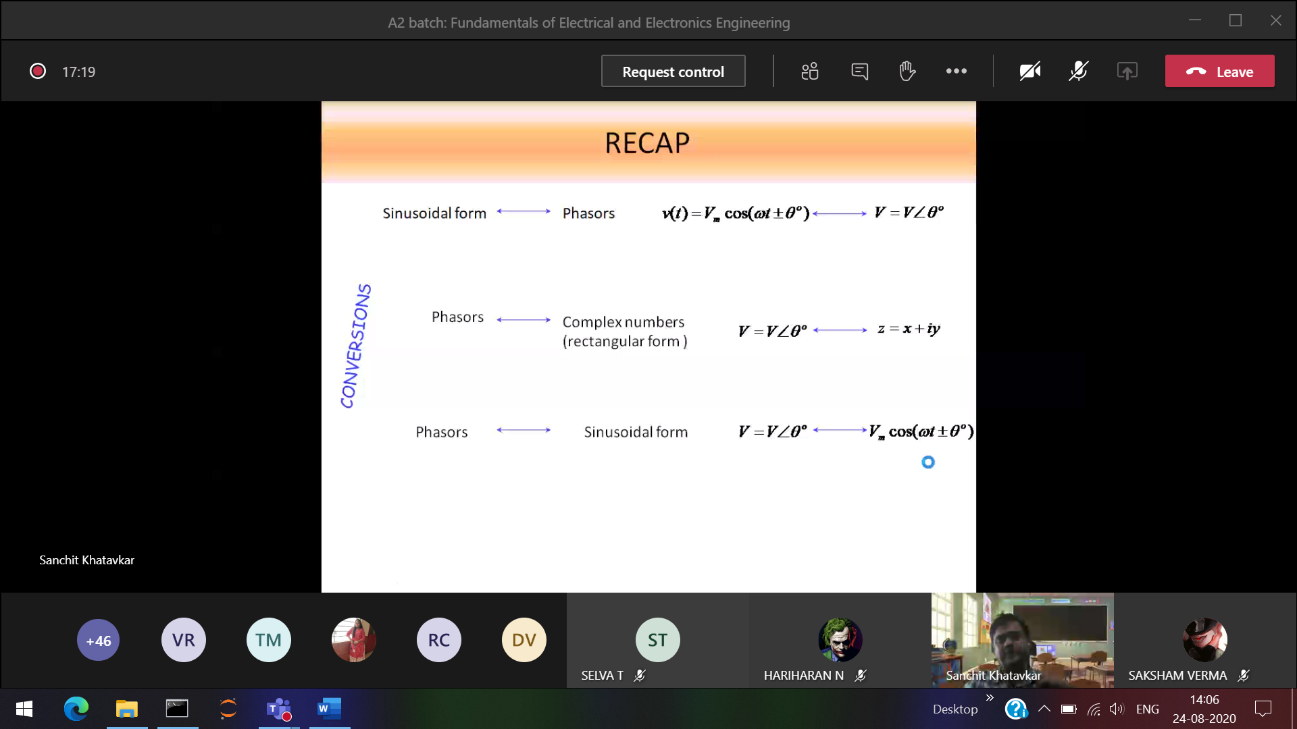

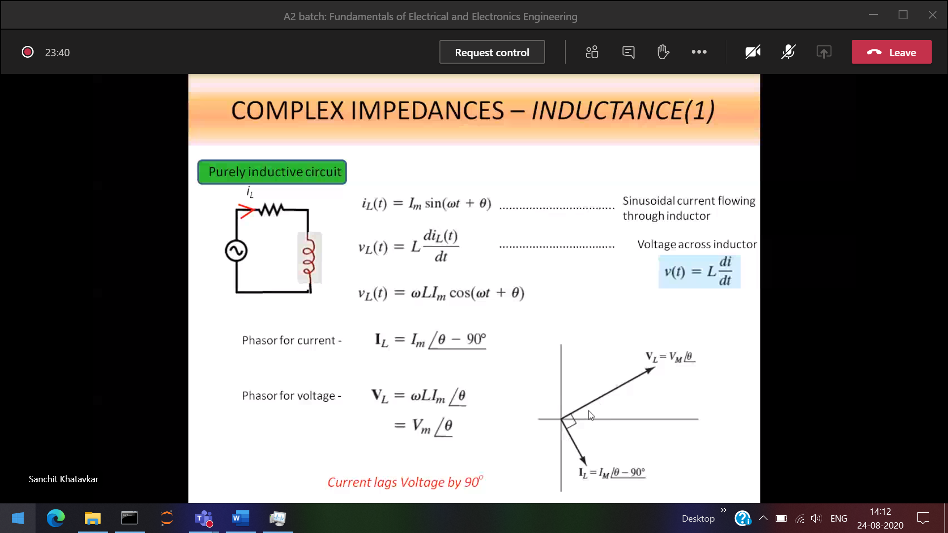

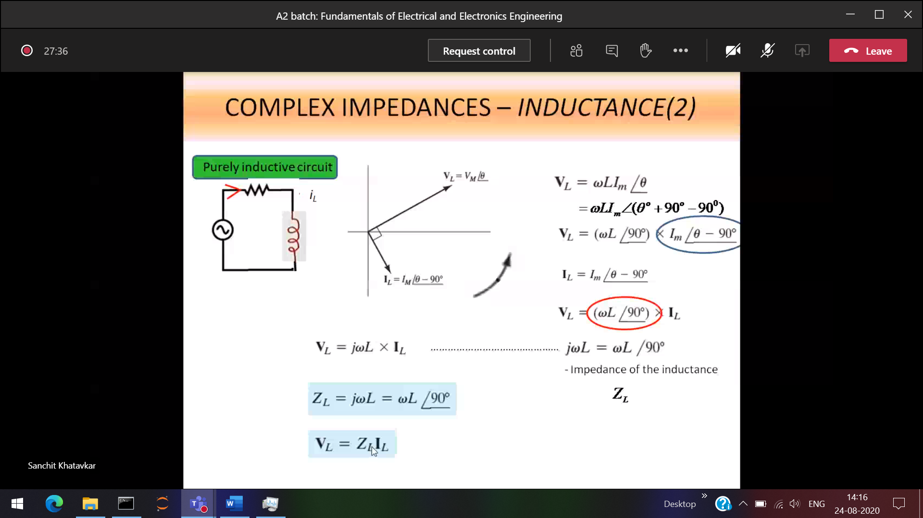

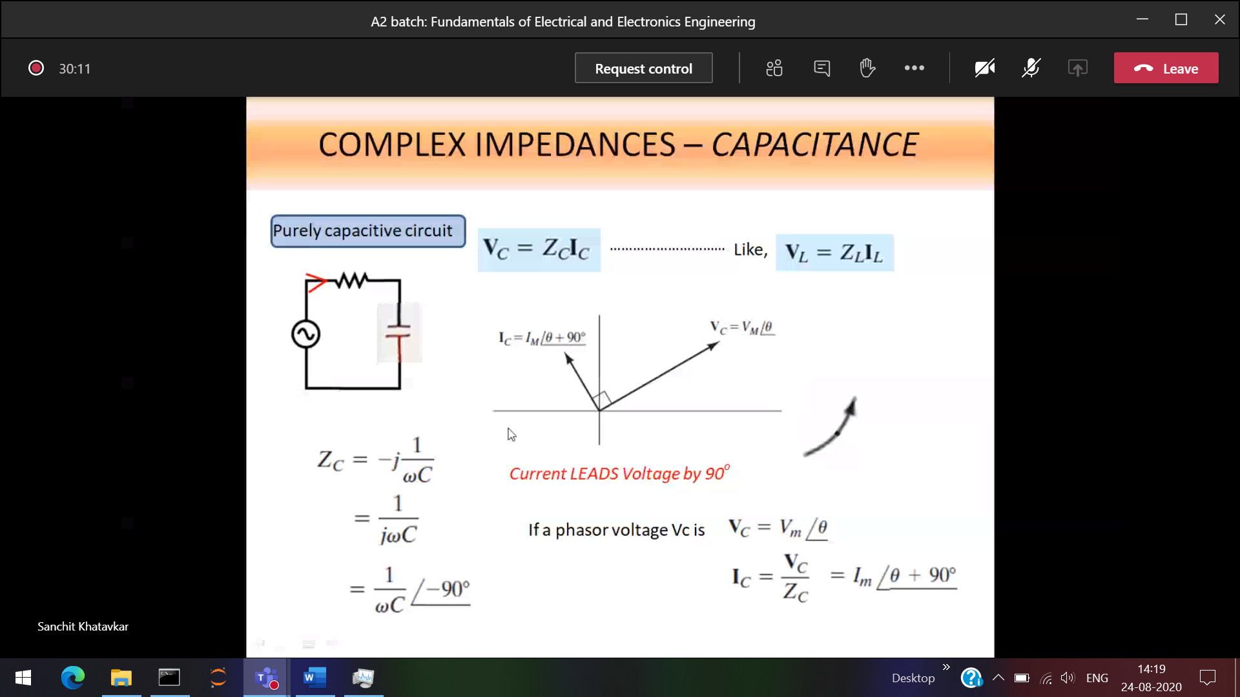

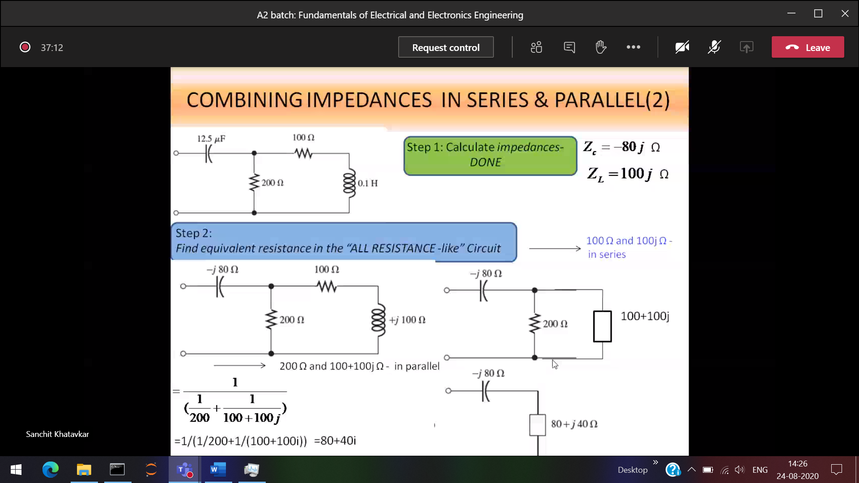

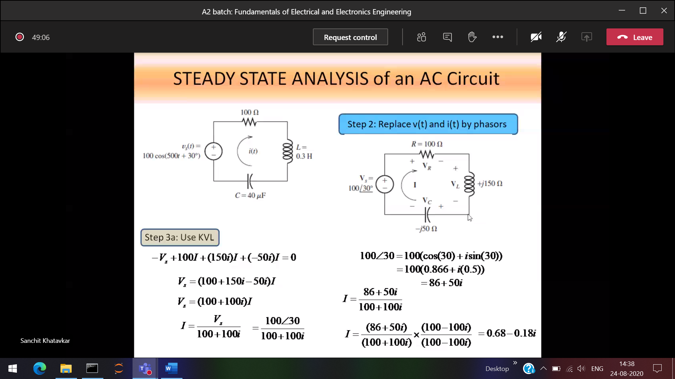

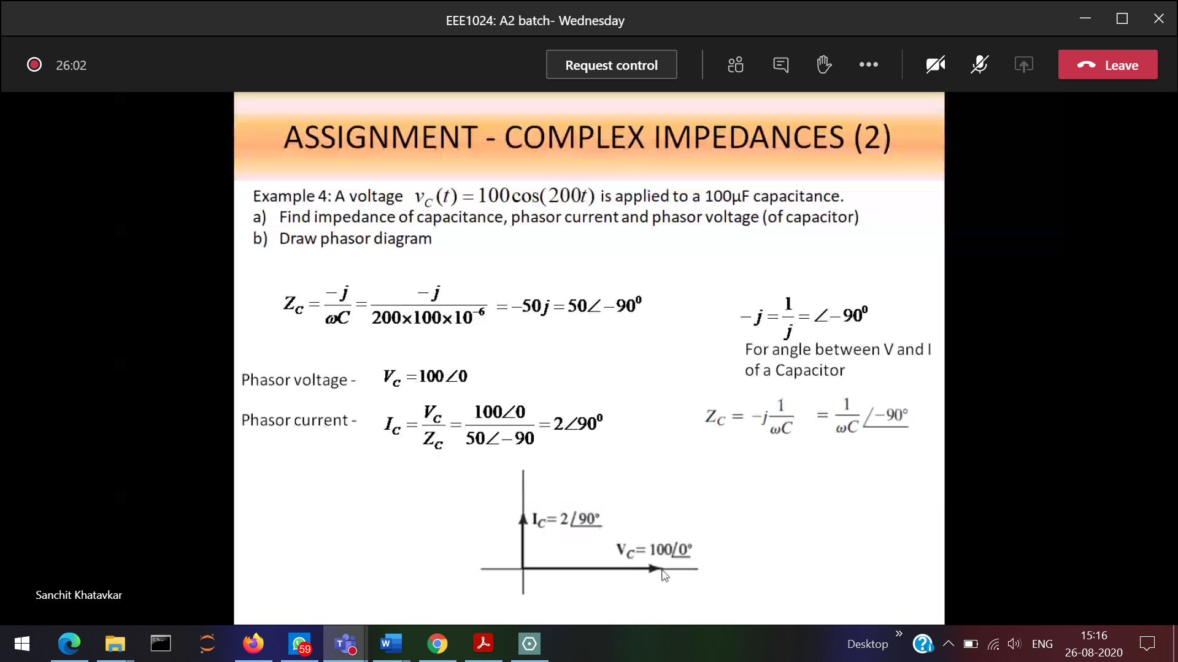

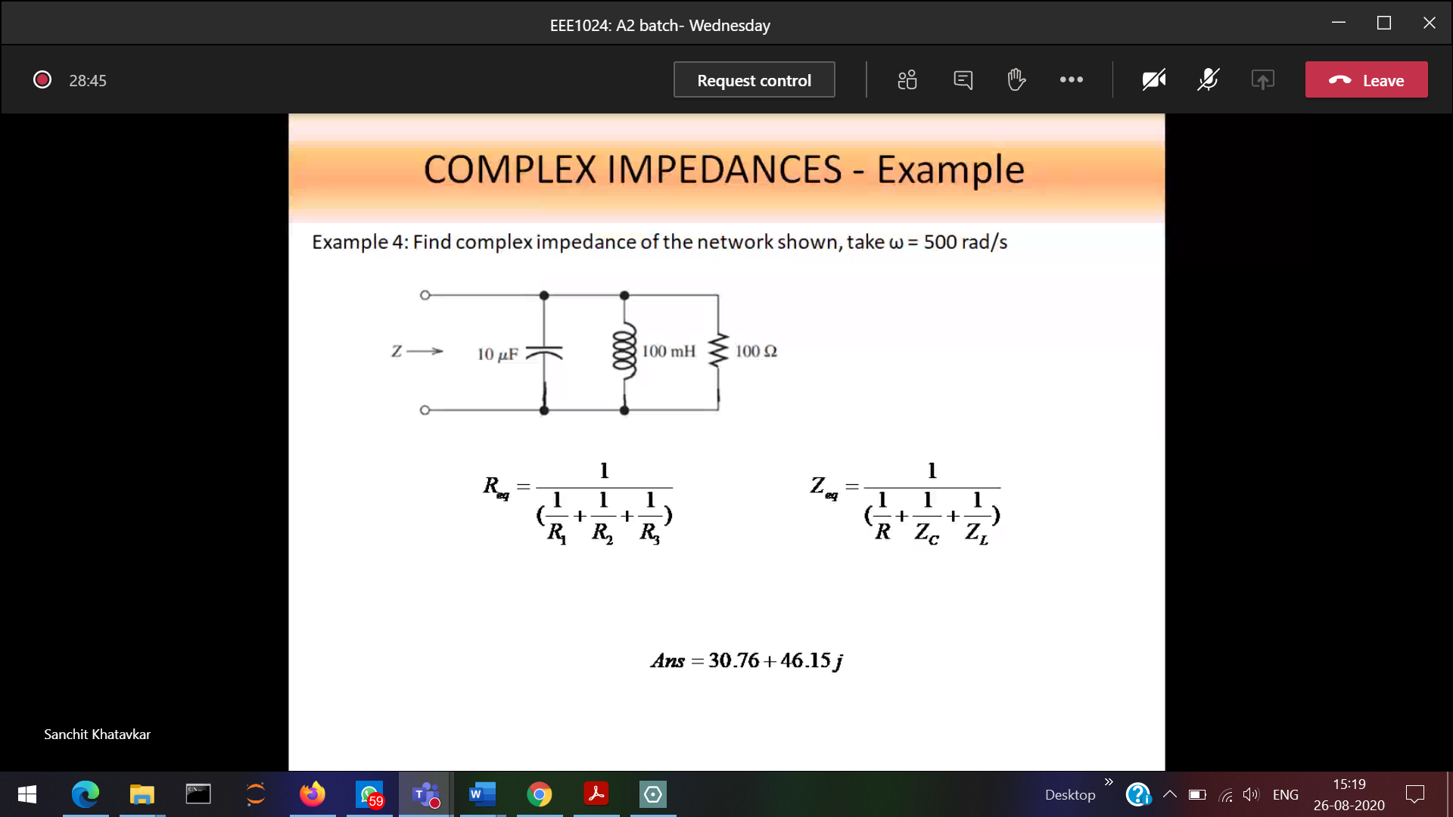

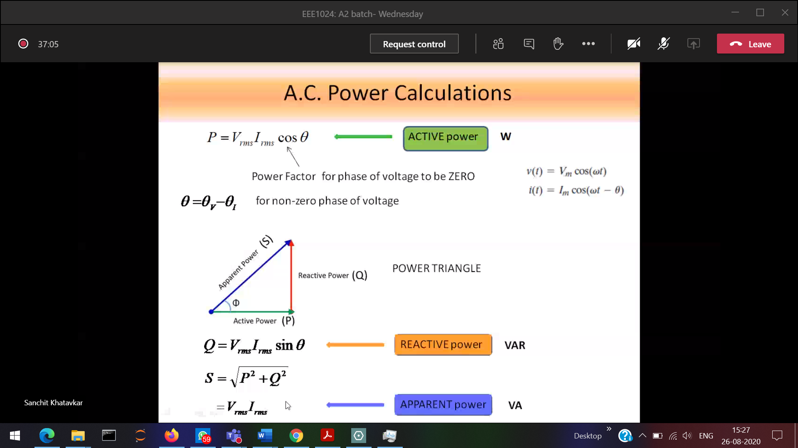

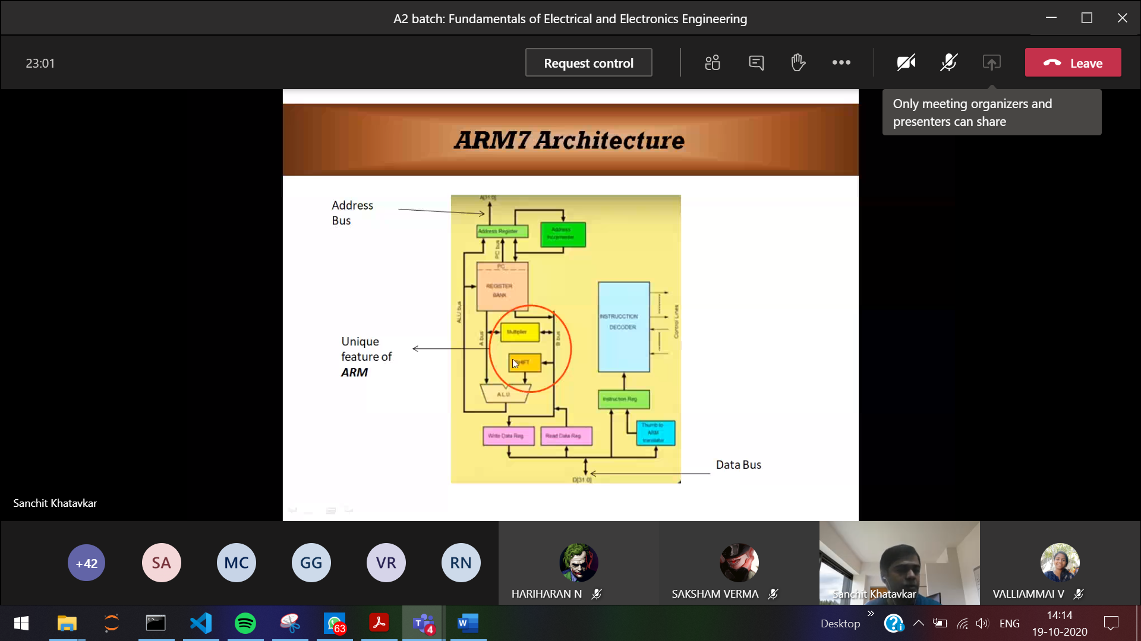

RISC 🡪 Alu takes only from Register (so only register is big) [ Can’t access from memory]  
Add both the bits (1 0) are in register  
CISC 🡪 Alu takes from both memory and register (so only register is small)  
Add both the bits (1 0 )  
1 🡪 register  
0 🡪 memory

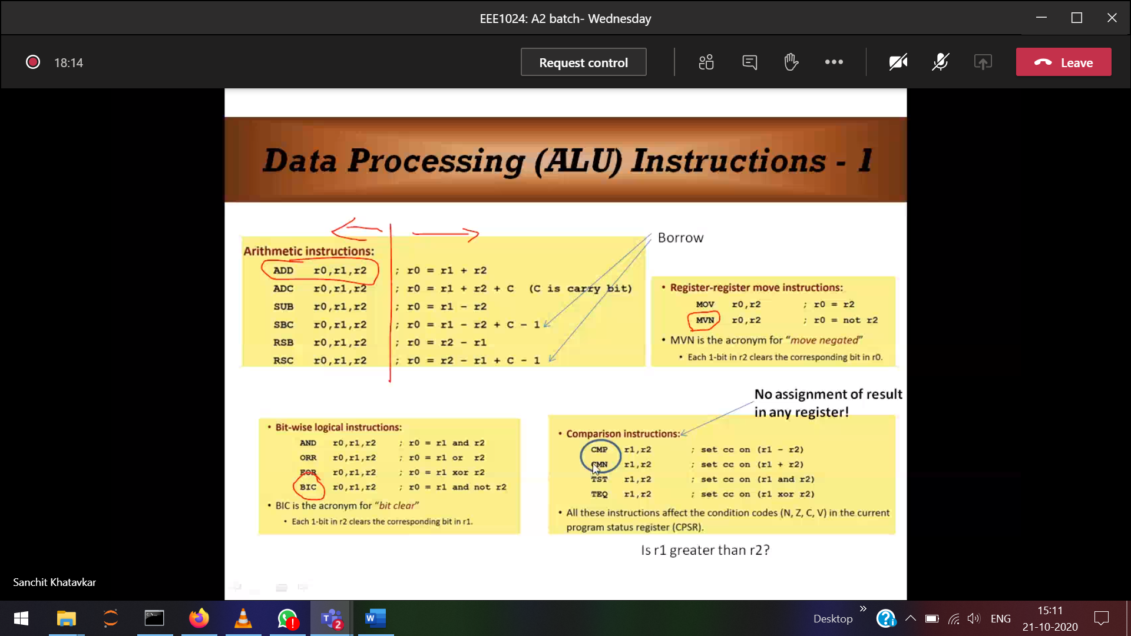

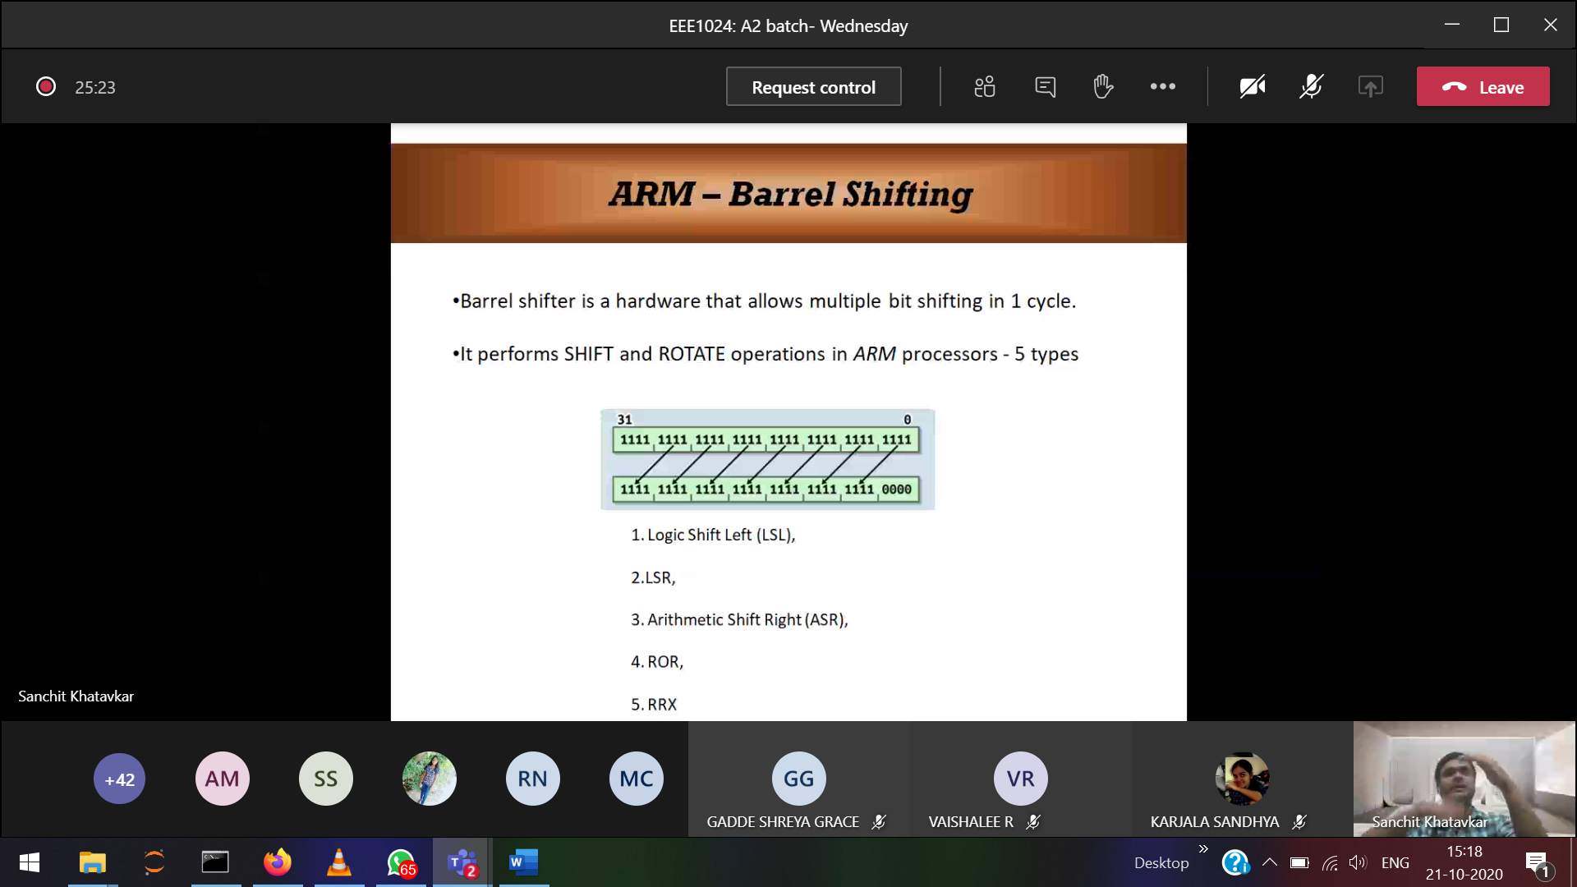

0000

.

.

1111

ArithmetRotate 🡪 0001 to 0010 ( 1 to 2)  
Barrel Shifter 🡪 for the purpose of rotating.

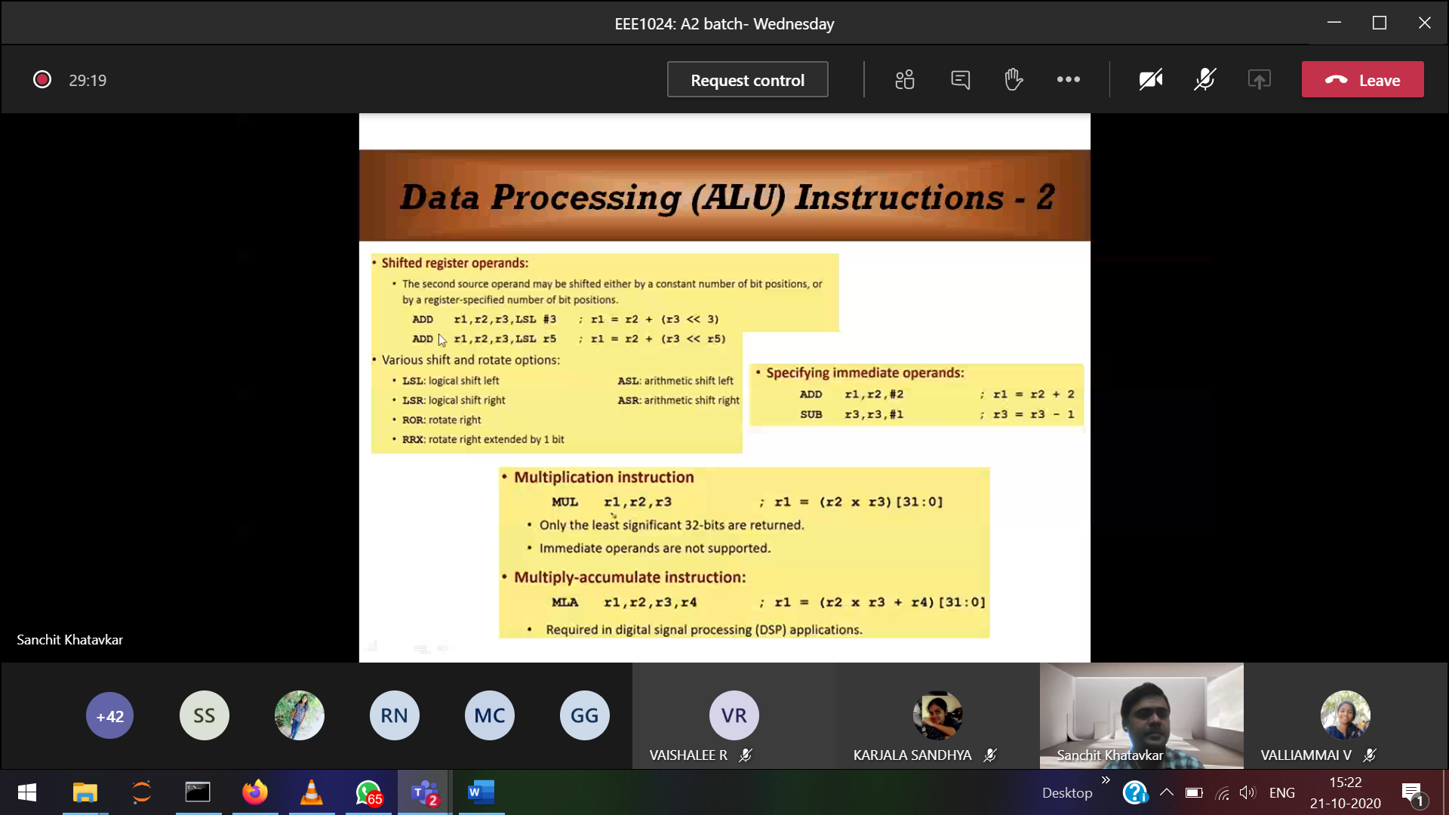

LSL #3 🡪 logical shift by 3 positions   
LSL r5 🡪 (whatever number of bits are in the register, move that number of bits)

[31:0] 🡪 32 bit multiplication

Accumulate 🡪 add

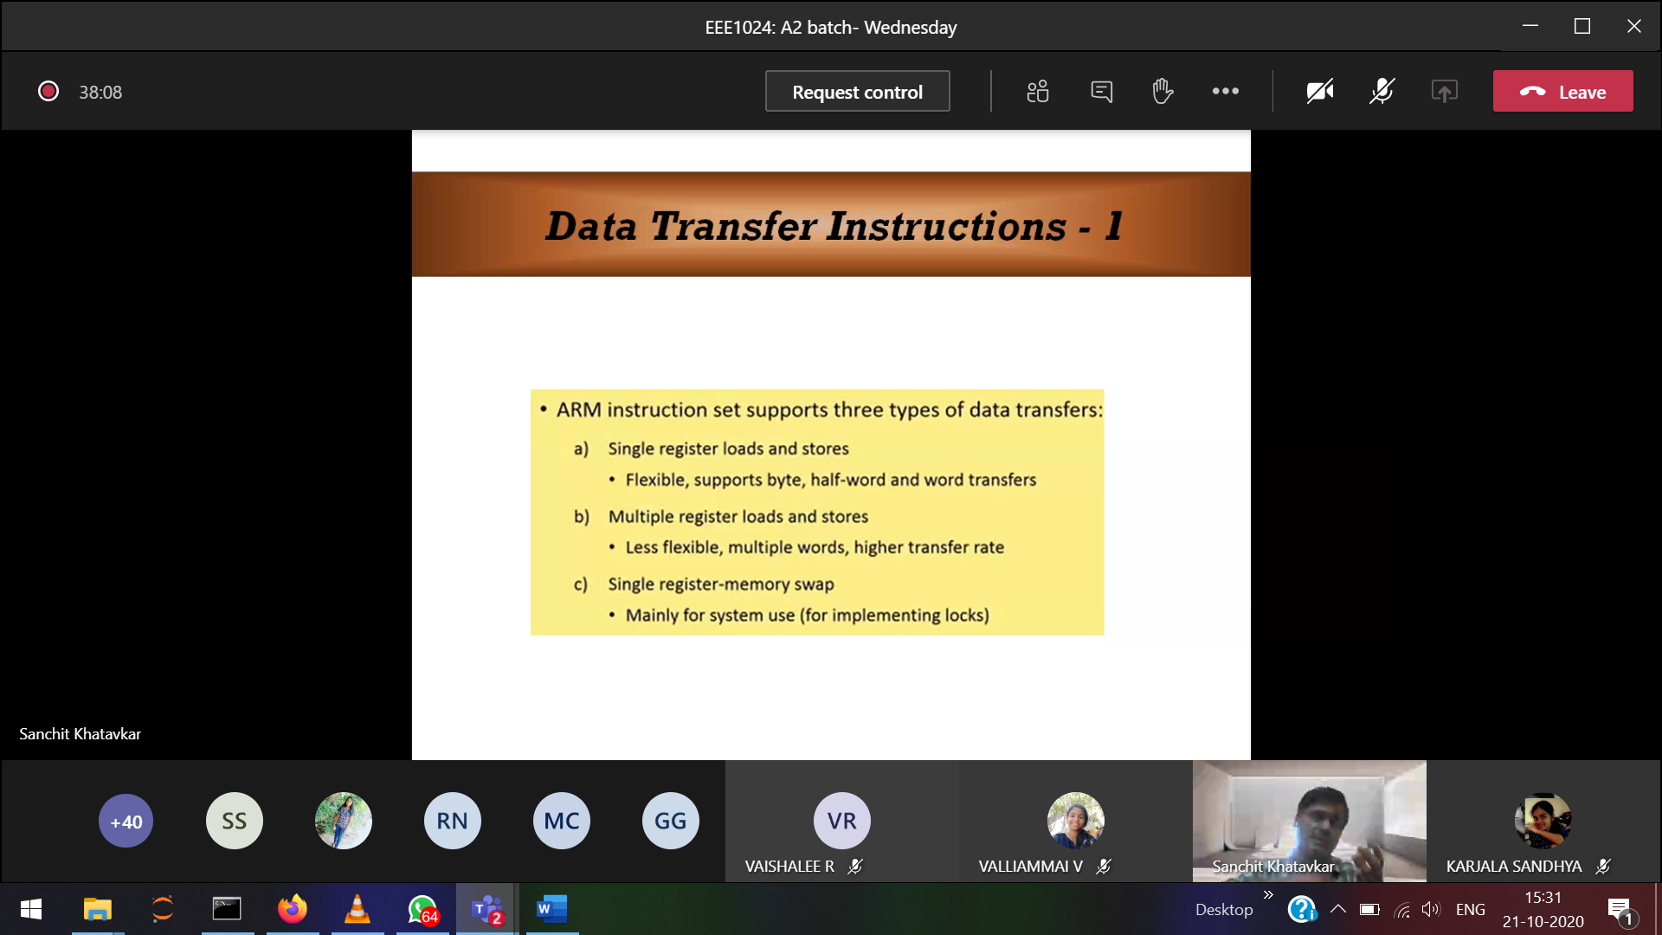

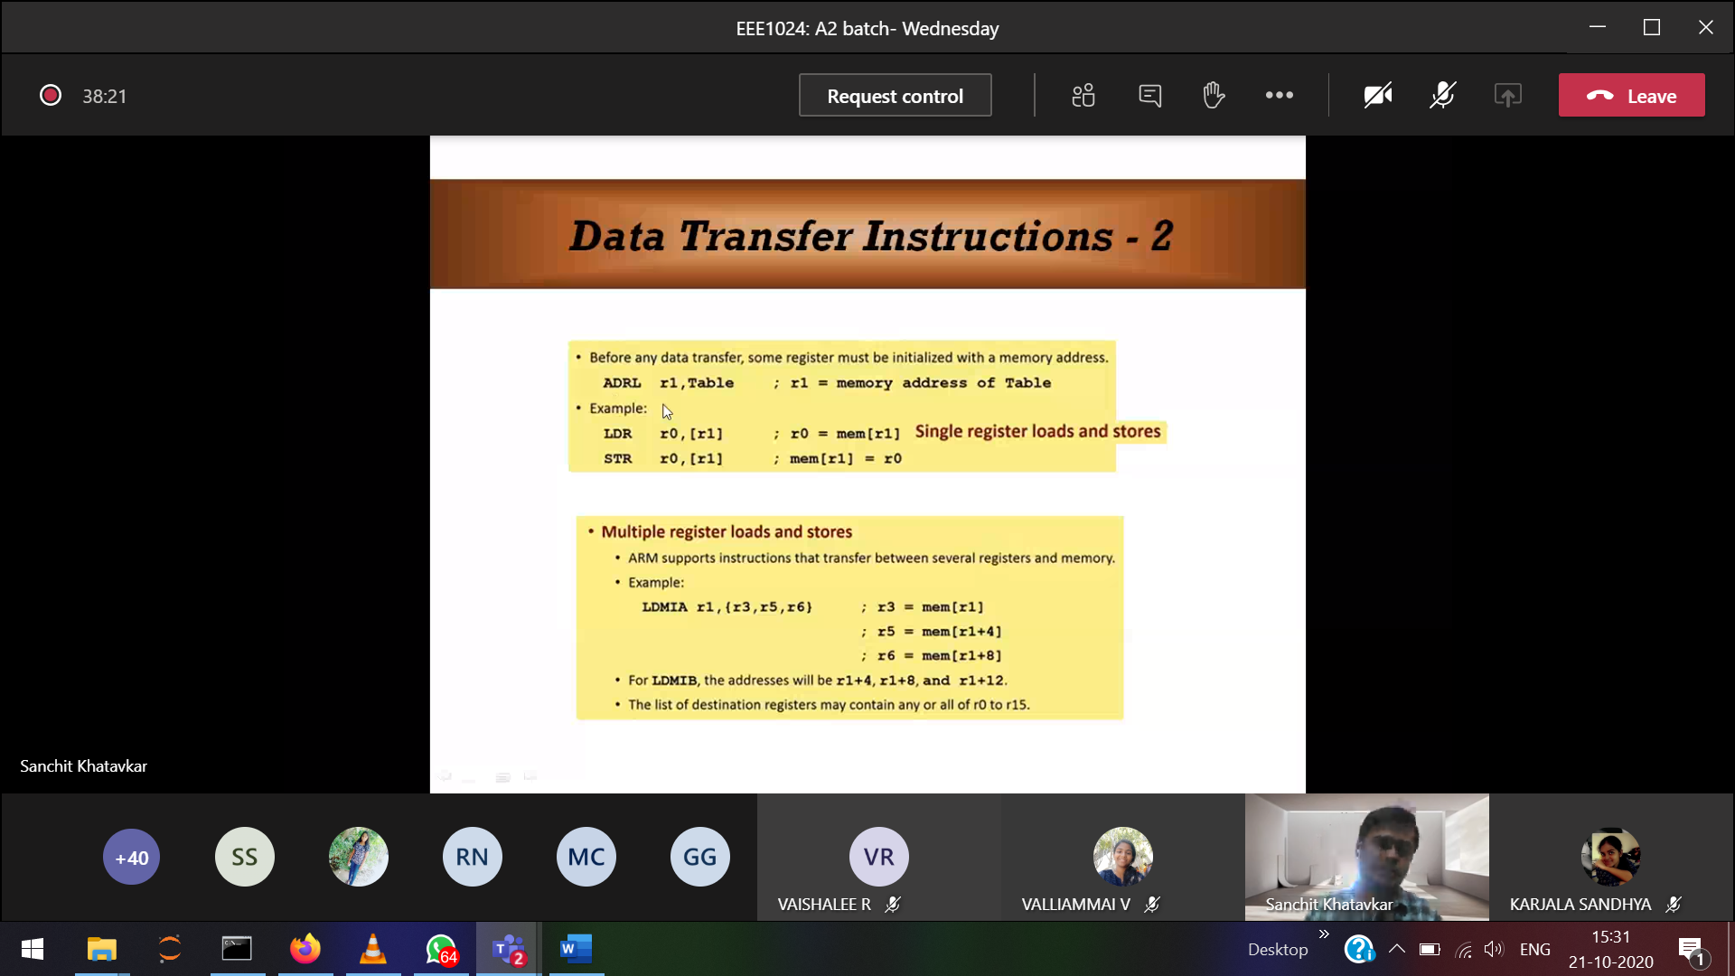

ADRL 🡪 like pointers

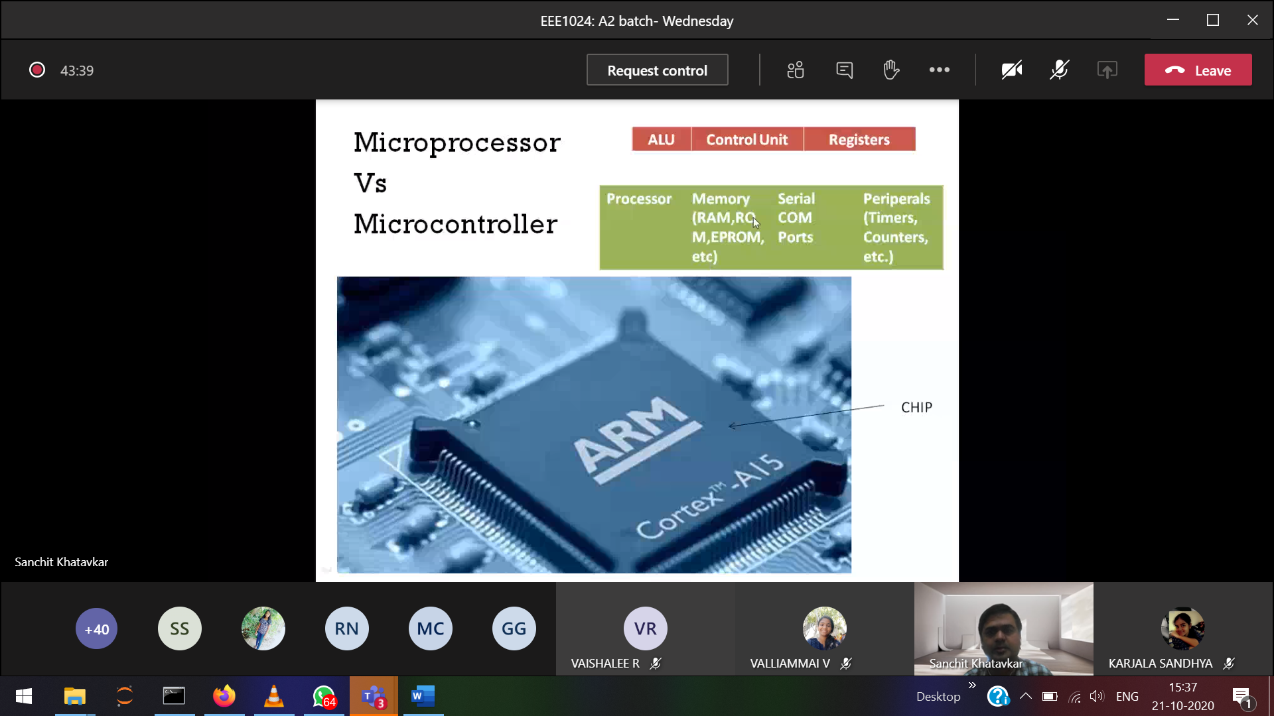

Processors 🡪 ALU,CU,Registers

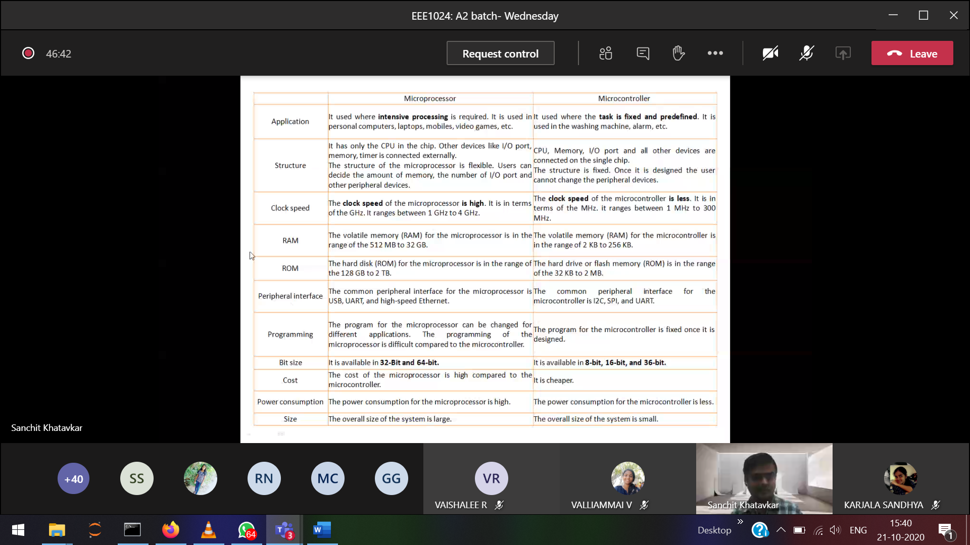

Micro-controller 🡪 eg: washing machine (fixed work)

Modern embedded systems are often based on [microcontrollers](https://en.wikipedia.org/wiki/Microcontroller)

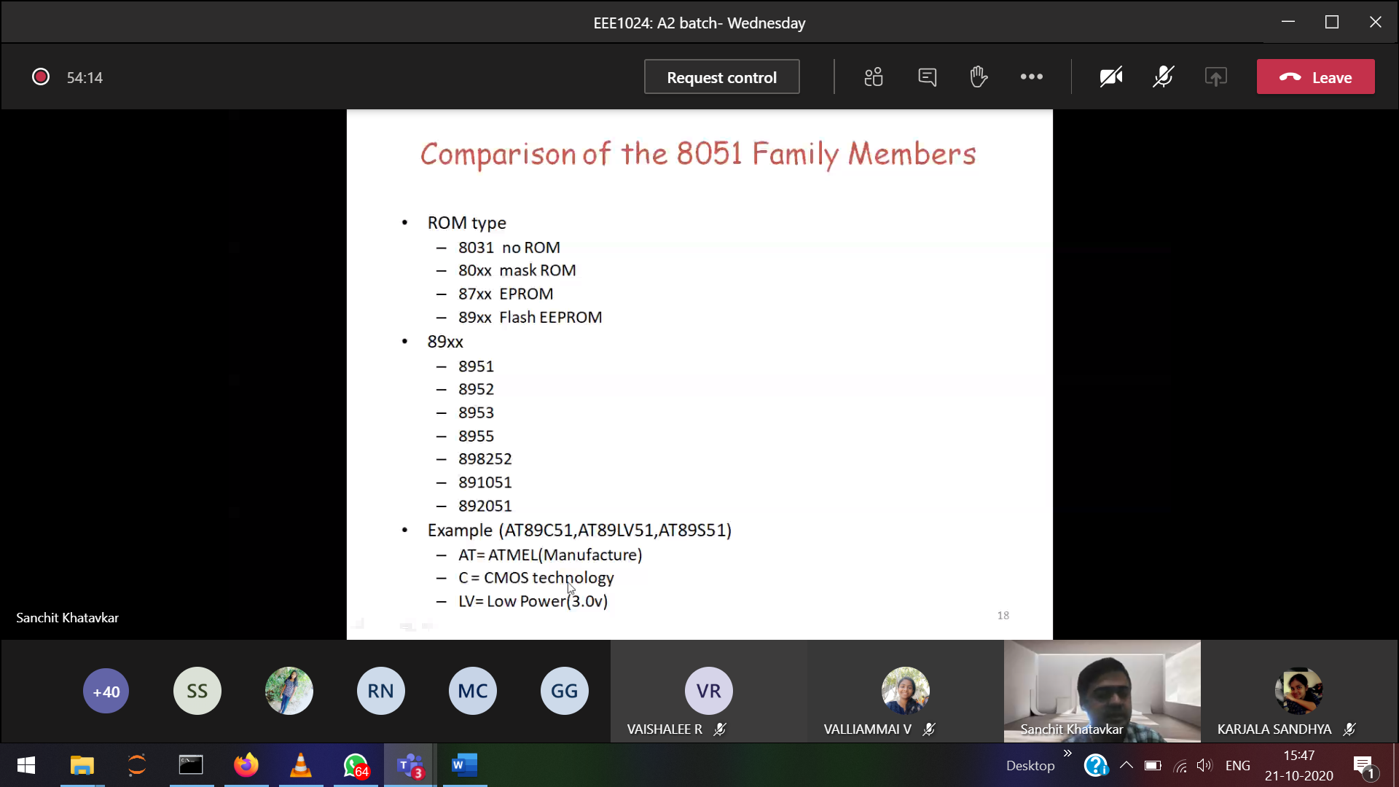

Cmos 🡪Bjt

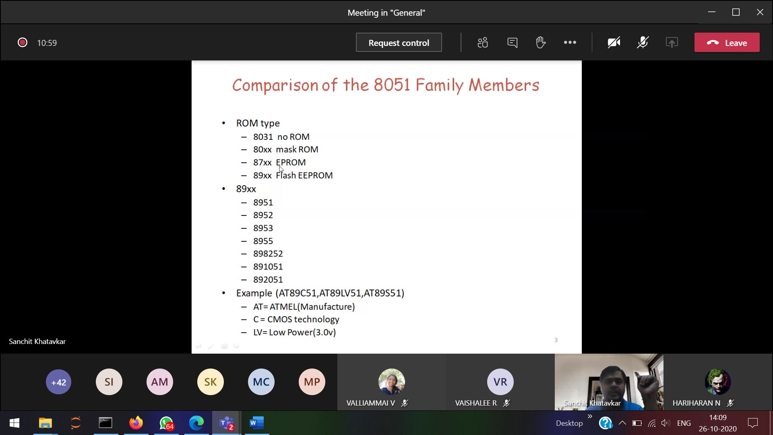

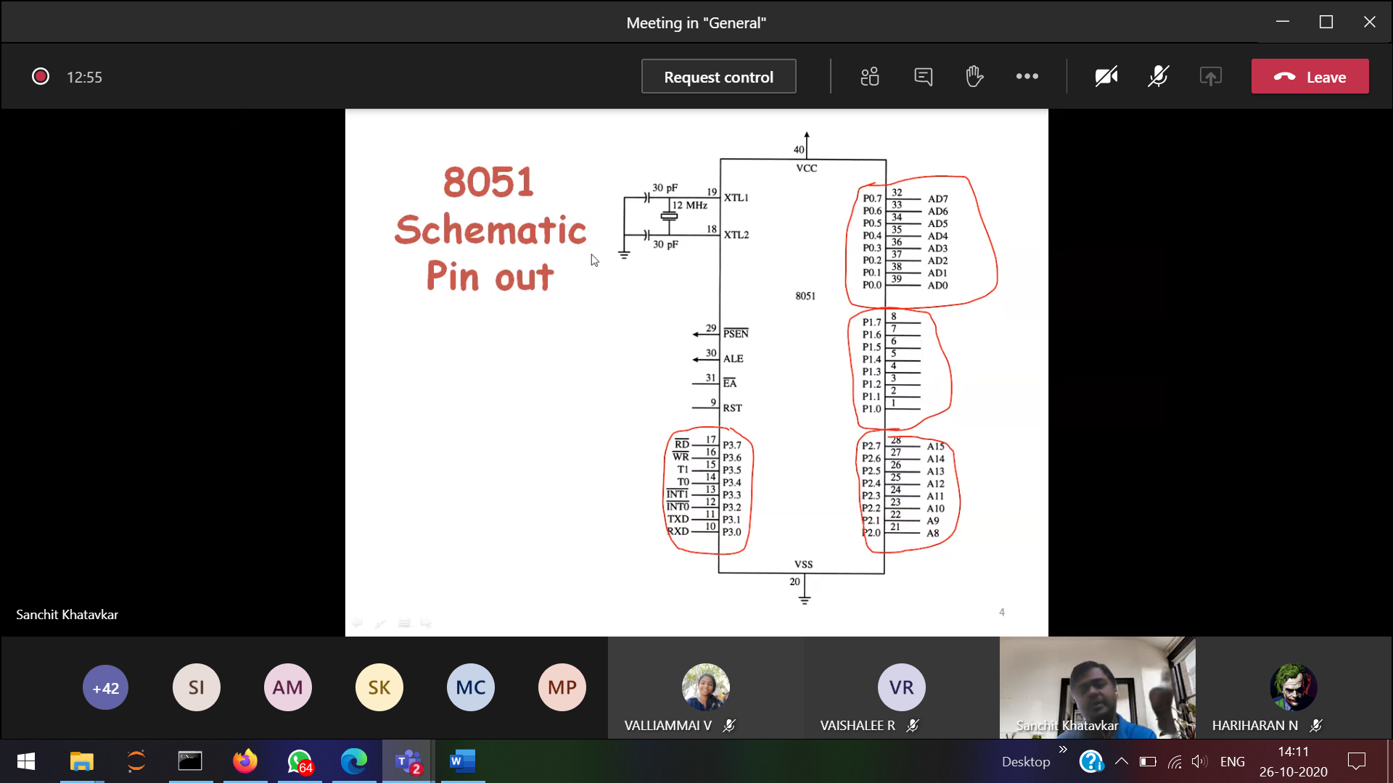

20 🡪 grounded

In schematic depending upon the application the ports can be changed.

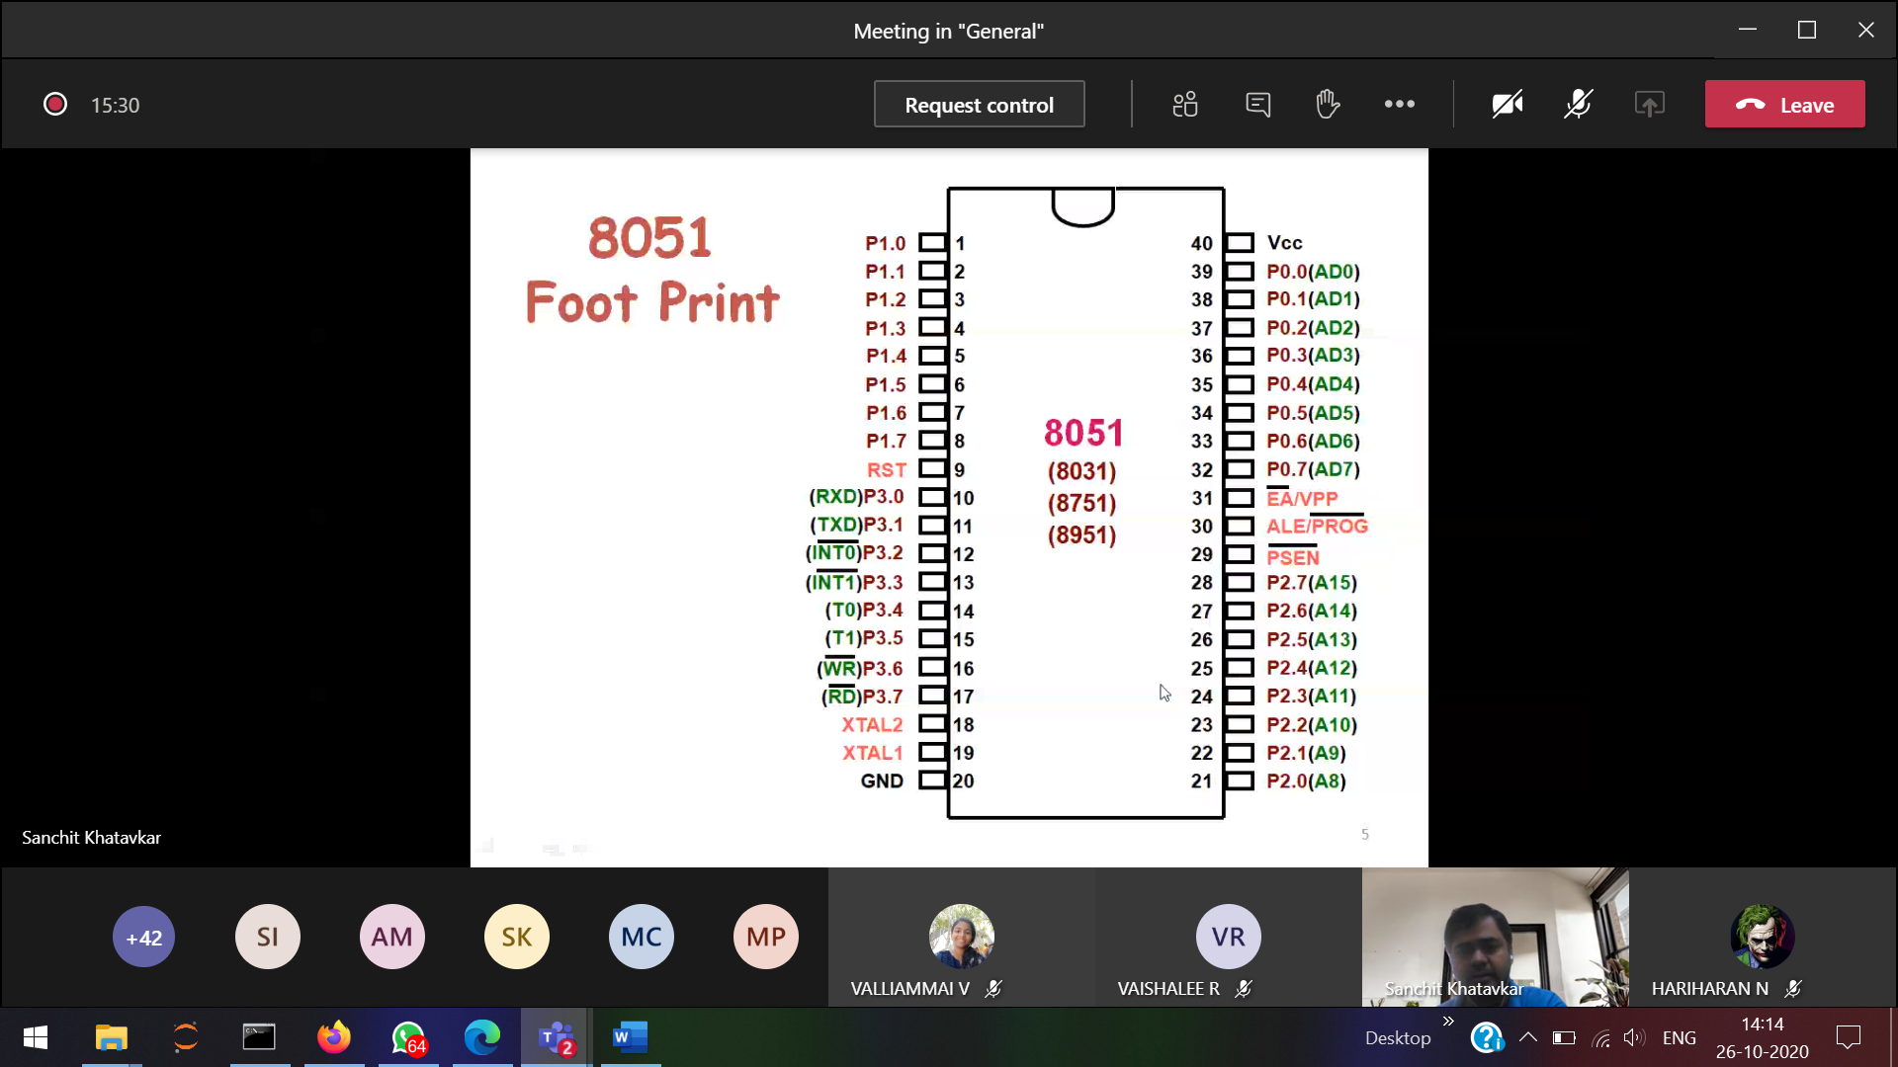

1,2,3,.. 40 🡪 Inside there is location

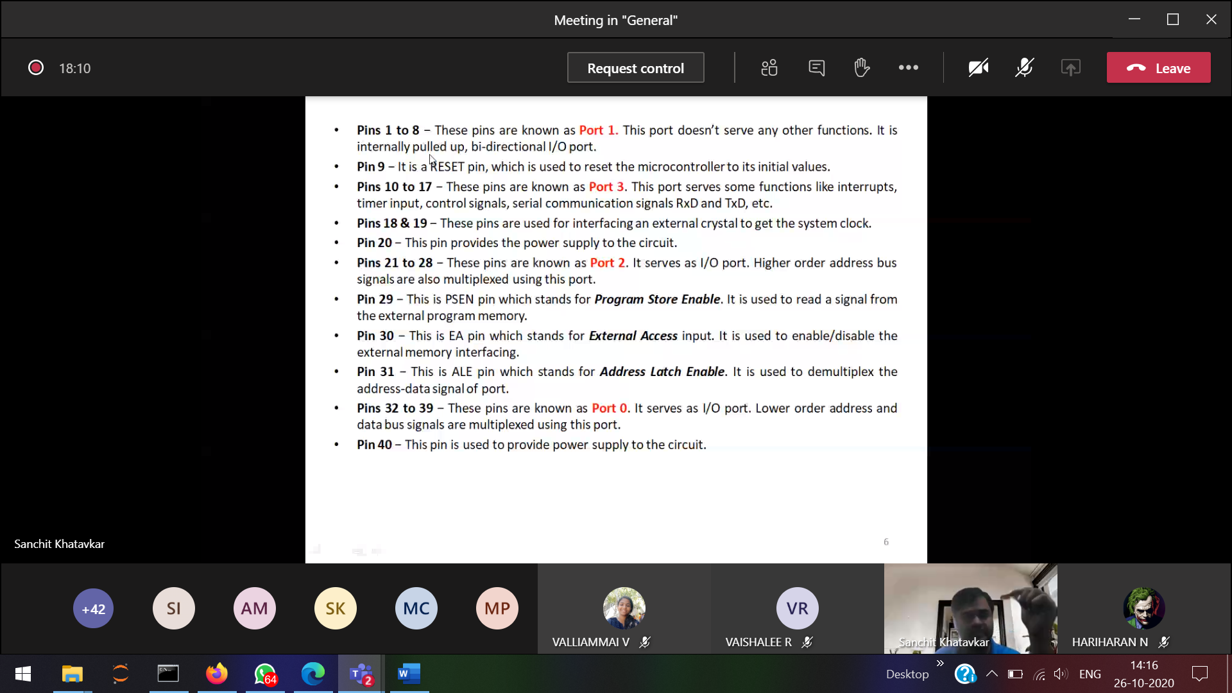

Port 🡪 collection of pins

Mux 🡪 1 to many  
demux 🡪 many to 1

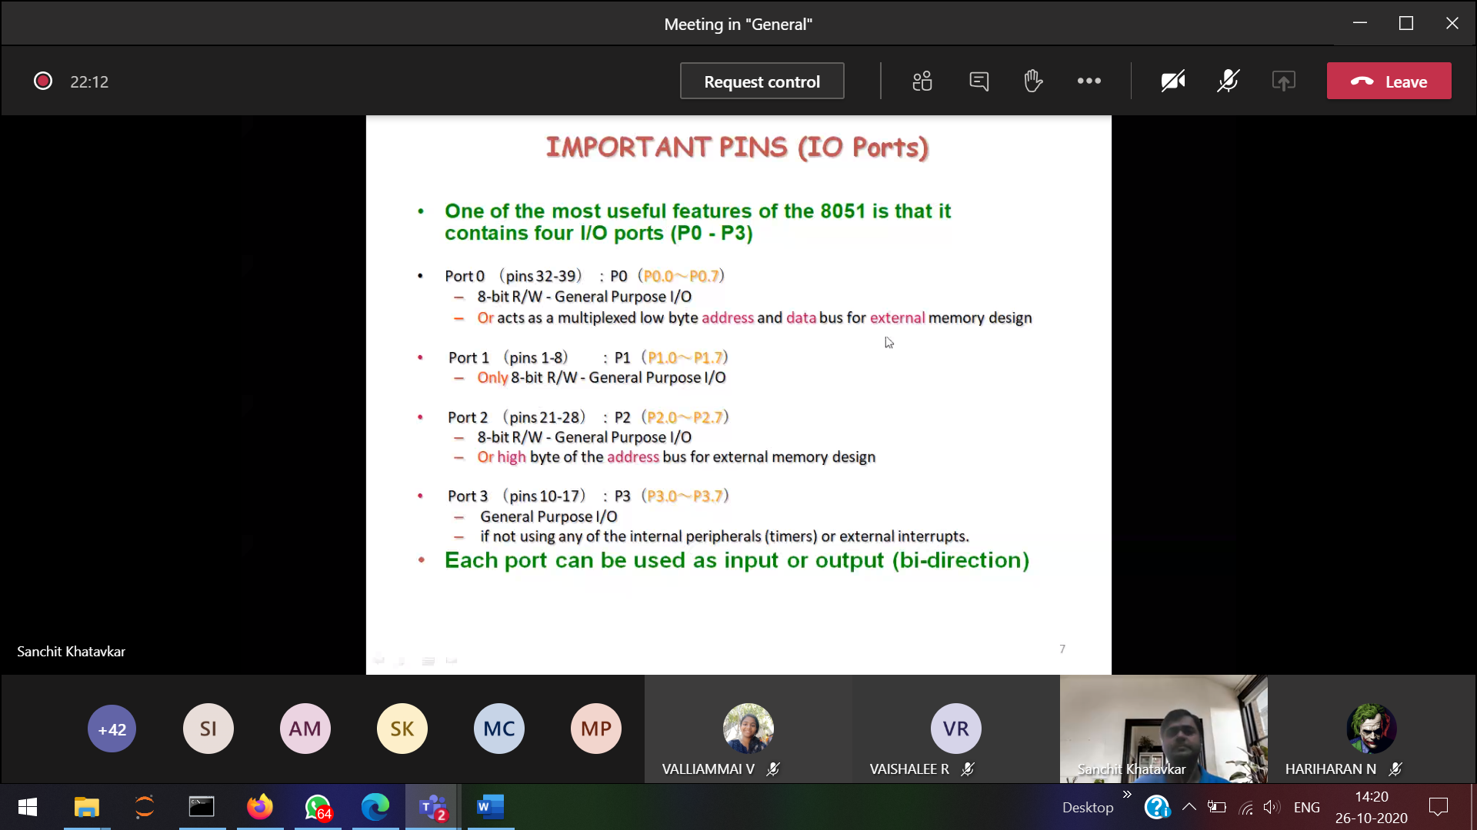

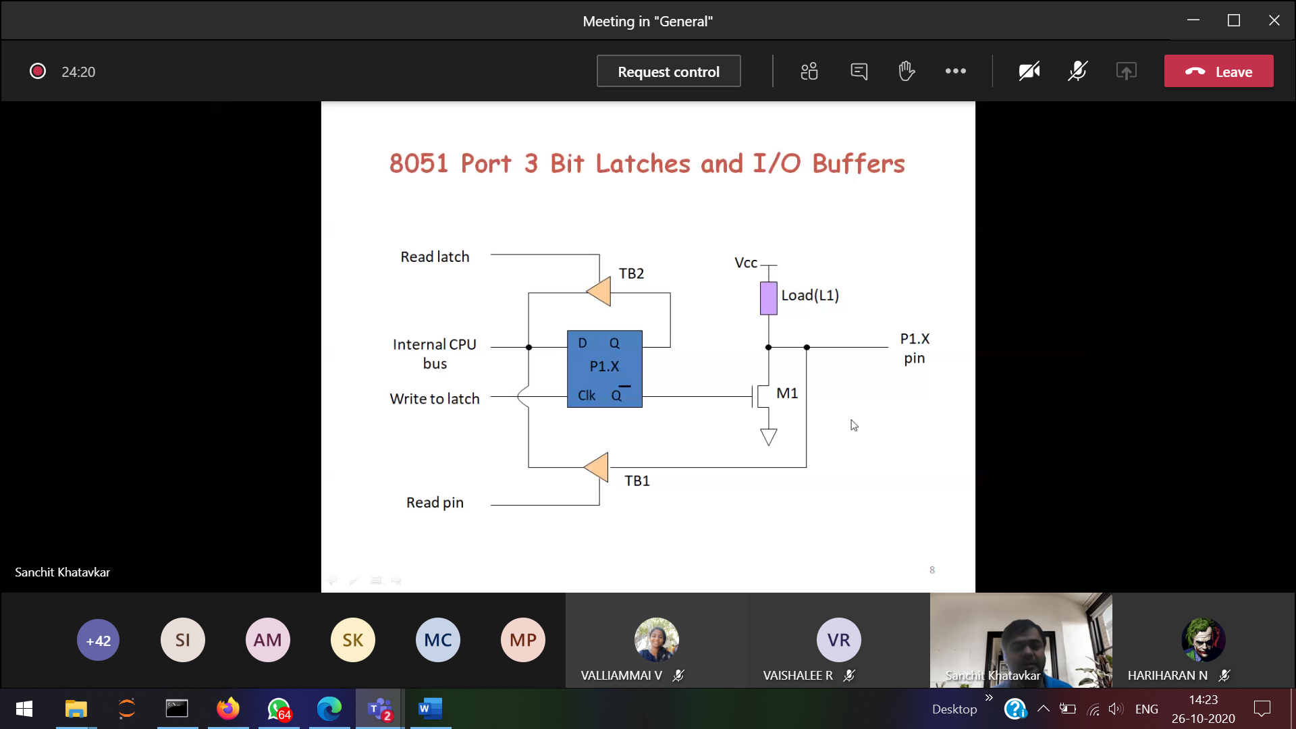D-flip flop is used.

(8051)Register 🡪 8 bits  
(ARM) Register 🡪 32 bits(maximum)

Assembly level coding

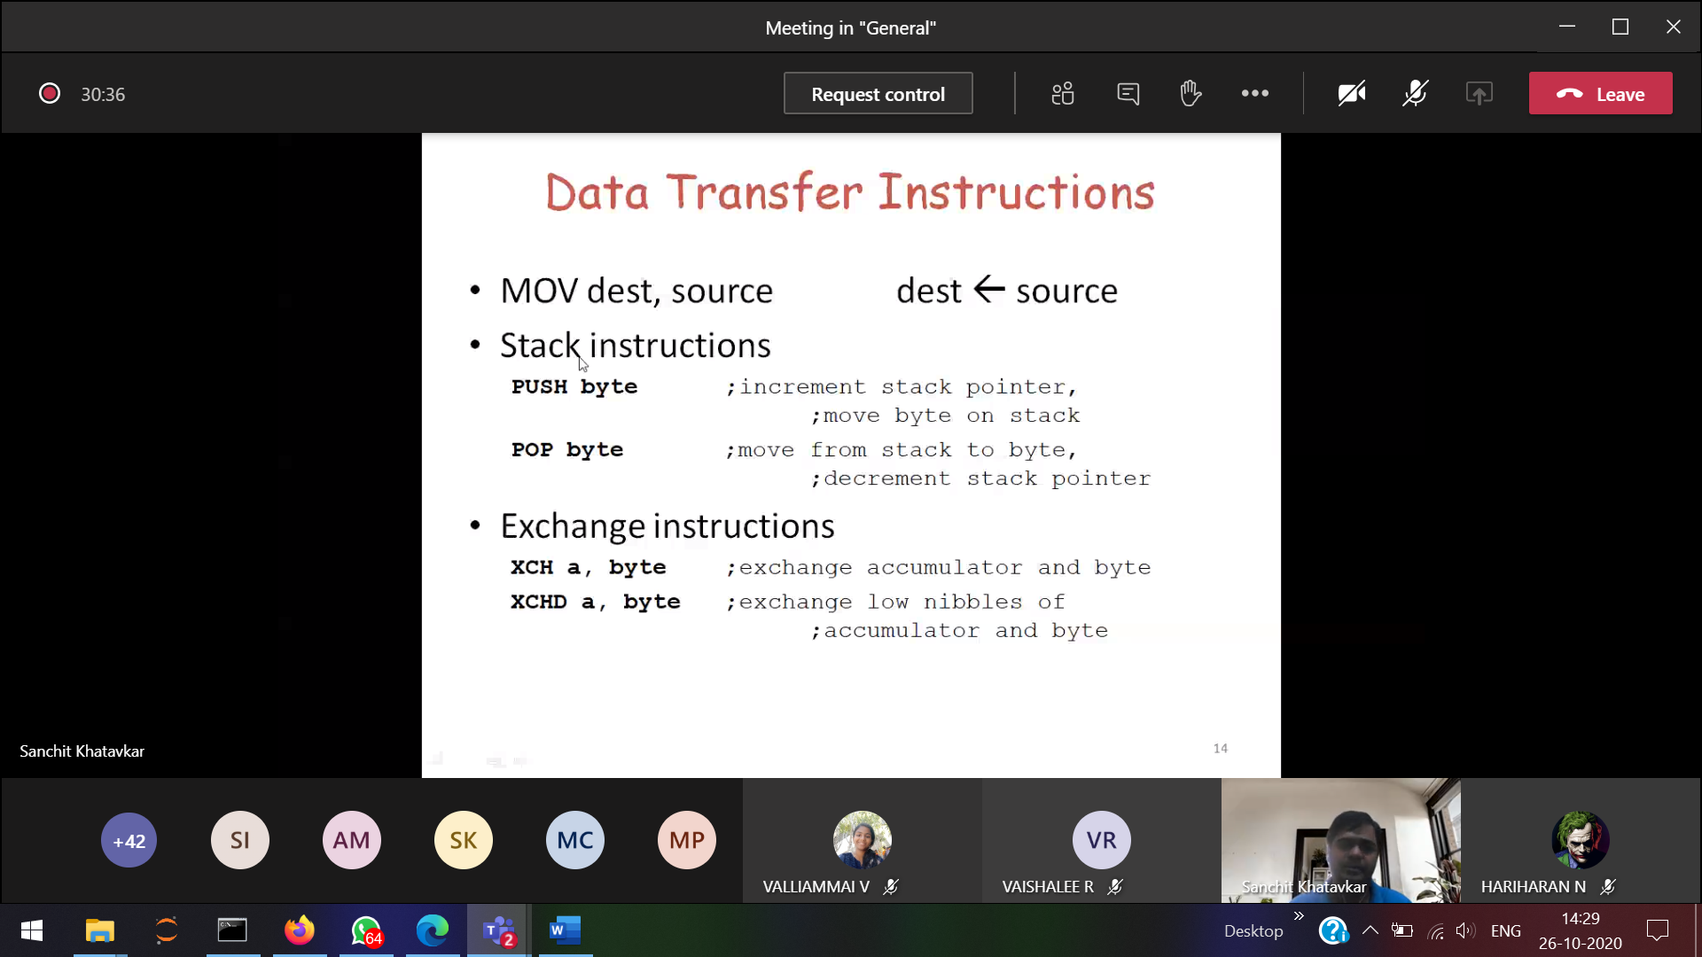

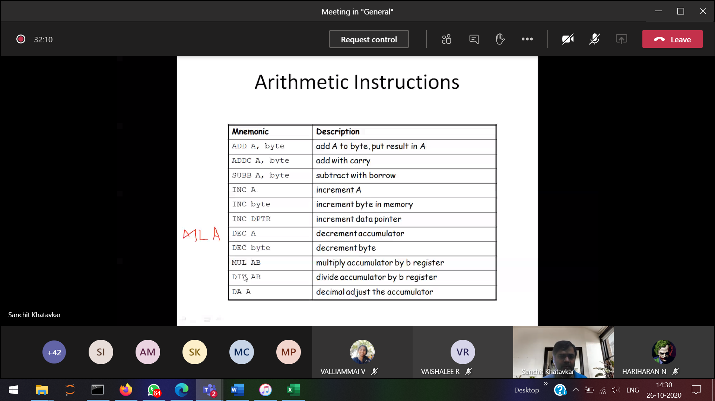

Instruction set of ARM is more powerful than 8051

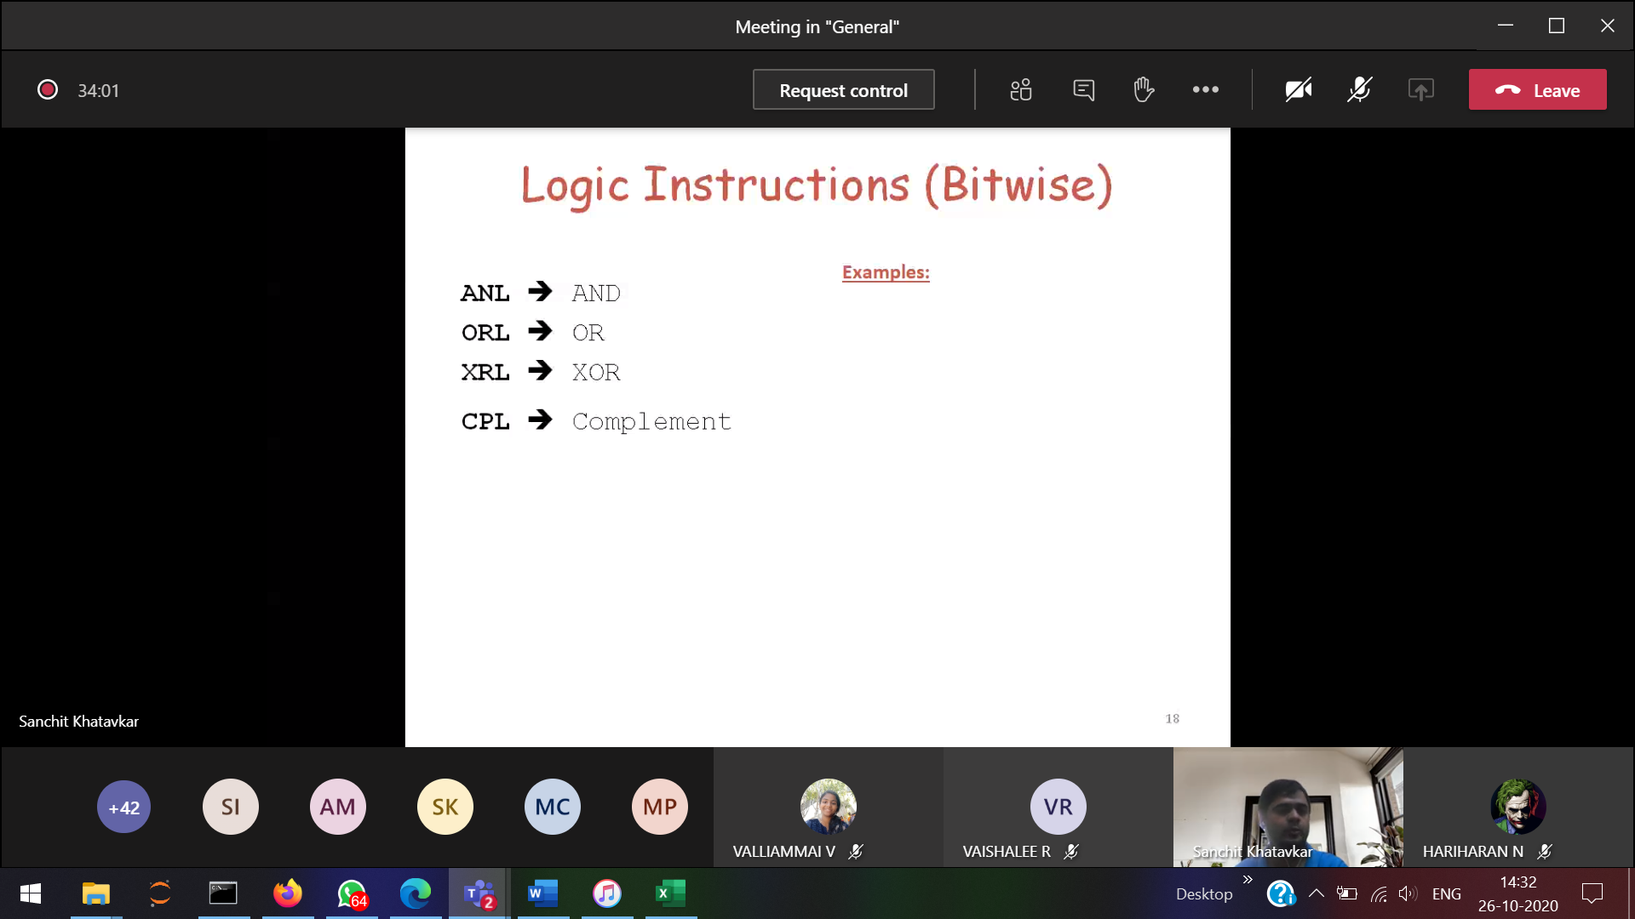

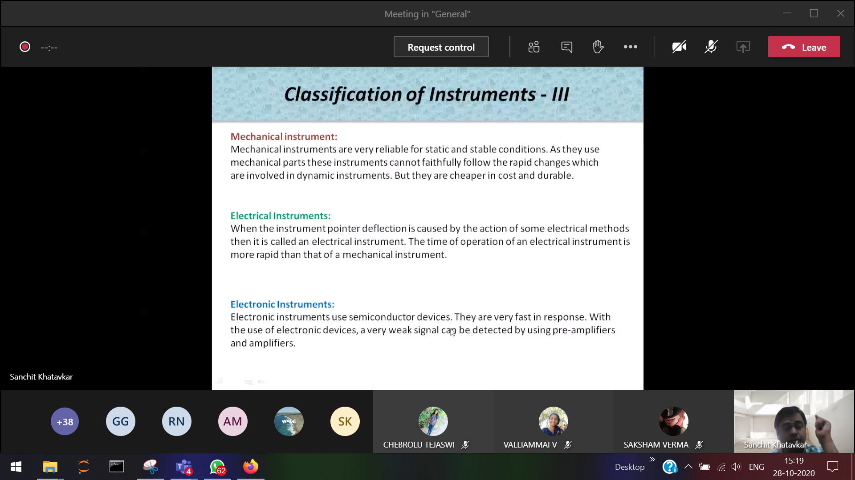

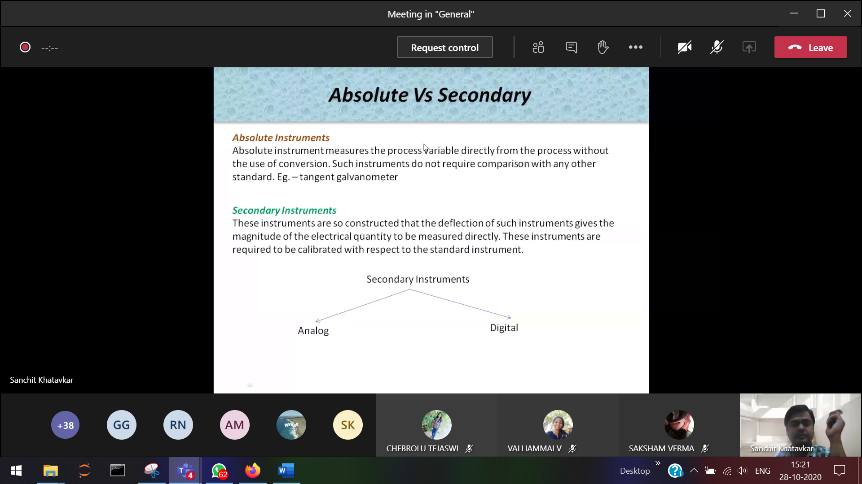  
Process variable 🡪 quantity that want to be measured

